## CR-05 - Goals and Outcomes

**Progress the jurisdiction has made in carrying out its strategic plan and its action plan. 91.520(a)**

This could be an overview that includes major initiatives and highlights that were proposed and executed throughout the program year.

**Comparison of the proposed versus actual outcomes for each outcome measure submitted with the consolidated plan and explain, if applicable, why progress was not made toward meeting goals and objectives. 91.520(g)**

Categories, priority levels, funding sources and amounts, outcomes/objectives, goal outcome indicators, units of measure, targets, actual outcomes/outputs, and percentage completed for each of the grantee’s program year goals.

|  |  |  |  |  |  |  |  |  |  |  |
| --- | --- | --- | --- | --- | --- | --- | --- | --- | --- | --- |
| **Goal** | **Category** | **Source / Amount** | **Indicator** | **Unit of Measure** | **Expected – Strategic Plan** | **Actual – Strategic Plan** | **Percent Complete** | **Expected – Program Year** | **Actual – Program Year** | **Percent Complete** |
| Administration | Administration | CDBG: $ | Other | Other | 1 | 1 | 100.00% | 1 | 1 | 100.00% |
| Home Improvement Program | Affordable Housing | CDBG: $ | Homeowner Housing Rehabilitated | Household Housing Unit | 110 | 123 | 111.82% | 15 | 32 | 213.33% |
| Home Improvement Program - Mechanical | Affordable Housing | CDBG: $ | Homeowner Housing Rehabilitated | Household Housing Unit | 60 | 84 | 140.00% | 12 | 19 | 158.33% |
| Mortgage, Rent & Utility Assistance | Public Services | CDBG: $ | Public service activities other than Low/Moderate Income Housing Benefit | Persons Assisted | 45 | 91 | 202.22% | 10 | 0 | 0.00% |
| Mortgage, Rent & Utility Assistance | Public Services | CDBG: $ | Public service activities for Low/Moderate Income Housing Benefit | Households Assisted |  | 0 |  |  |  |  |
| Project I.M.P.A.C.T. | Affordable Housing | CDBG: $ | Public service activities other than Low/Moderate Income Housing Benefit | Persons Assisted | 0 | 0 |  |  |  |  |
| Project I.M.P.A.C.T. | Affordable Housing | CDBG: $ | Homeowner Housing Rehabilitated | Household Housing Unit | 50 | 104 | 208.00% | 17 | 27 | 158.82% |

Table 1 - Accomplishments – Program Year & Strategic Plan to Date

**Assess how the jurisdiction’s use of funds, particularly CDBG, addresses the priorities and specific objectives identified in the plan, giving special attention to the highest priority activities identified.**

The City of Florissant concentrated the use of its CDBG funds in affordable housing related activities in Program Year 2024. The following programs were identified in our Program Year 2024 Annual Action Plan: (1) Home Improvement Program, (2) Home Improvement Program-Mechanical, (3) Project IMPACT, (4) Mortgage Rent and Utility Assistance Program, and (5) Program Planning and Administration. During PY2024 the City provided 0% interest, five-year forgivable loans to assist 32 low-moderate income homeowners make repairs and improvements to their homes.  In addition, the city provided grants to 19 low-moderate income homeowners to replace heating and cooling units.  Through the Project IMPACT program, the City provided funds to allow 27 residents who are disabled, elderly and/or low income with handicapped home modifications or assistance with the exterior upkeep of their homes.

An allocation of $0 was set aside for the Mortgage Rent and Utility Assistance Program, due to the lack of need for funds in prior years and due the availability of our MRU-CV funds and other federal programs offering assistance with mortgage and rent. In 2024, with no additional funds available, this program provided mortgage, rent and/or utility assistance to 0 people who faced emergency or severe temporary economic hardship**.  Our office has received a number of inquiries for funding, and we anticipate that funds will be expended in this program in 2025.**

During PY2020 the city was notified of $393,696 of additional funding under the CDBG-CV (CARES Act funding) allocation and in PY2022 began the implementation of 4 programs for the priority needs of the residents with the CDBG-CV funds. With this additional funding, these programs were created to address COVID related needs: The extension of the MRU-Assist Program was allocated $142,457, we contracted with CAASTLC to administer this program and in 2024 assisted 0 people with Mortgage Rent and Utility Assistance. The feedback that we received from our subgrantee was that unexpended funds that can no longer meet the covid tie-back requirements.  We are in process of amending the 2019 Annual Plan to a program that will utilize the remaining funds in ways that will benefit residents of our city and will tie-back to the COVID-19 crisis. The HIP-CV Program was closed out in 2023. Mobile COVID Testing was closed out in 2023. The Food Bank-CV program was closed in 2023.  In 2024, Administration funds for the CDBG-CV allocation were used to study the impacts of COVID-19 on the housing in Florissant to provide a greater understanding of the housing needs of residents.

When preparing this report, the City of Florissant pulled form PR03 and PR23 to assist in assuring the accuracy of this report.  There are a few disagreements between this CAPER and the PR03 and PR23.  Some funds were drawn in 2024, but expended and reported on in 2023.  Also, thru Project IMPACT, residents are assisted by volunteers.  In some cases, no new CDBG funding was used, but tools purchased with CDBG funding were used to accomplish the projects, so those residents were noted as assisted in the CAPER, but otherwise noted in IDIS.

## CR-10 - Racial and Ethnic composition of families assisted

**Describe the families assisted (including the racial and ethnic status of families assisted). 91.520(a)**

|  |  |
| --- | --- |
|  | **CDBG** |
| White | 34 |
| Black or African American | 44 |
| Asian | 0 |
| American Indian or American Native | 0 |
| Native Hawaiian or Other Pacific Islander | 0 |

|  |  |  |
| --- | --- | --- |
|  |  | |
| **Total** | **78** |

|  |  |  |
| --- | --- | --- |
|  |  | |
| Hispanic | 2 |
| Not Hispanic | 76 |

**Table 2 – Table of assistance to racial and ethnic populations by source of funds**

**Narrative**

## CR-15 - Resources and Investments 91.520(a)

**Identify the resources made available**

|  |  |  |  |
| --- | --- | --- | --- |
| **Source of Funds** | **Source** | **Resources Made Available** | **Amount Expended During Program Year** |
| CDBG | public - federal | 328,432 | 291,209 |

Table 3 - Resources Made Available

**Narrative**

The City of Florissant qualified as an Entitlement Community in the late 1979/early 1980’s. The 2020 Census estimates the city’s population at 52,533. Total disbursements during PY2024 included prior year projects that were worked on and/or completed during the program year. CDBG program is funded entirely with funds received from HUD on a yearly basis.  In the 2024 Annual Plan, we noted that we received $279,583 as entitlement funds.  We also anticipated receiving $48,849 in NSP Program Income.  While the program income funds have been requested, we are still waiting for the disbursement.

The city received $393,696 of additional funding from CARES ACT and it is important to note the FY2020 & FY2021 were not accessible to expend until late 2021.  In 2022 and 2023, the city struggled to meet timeliness, but we met that goal in 2024.

**Identify the geographic distribution and location of investments**

|  |  |  |  |
| --- | --- | --- | --- |
| **Target Area** | **Planned Percentage of Allocation** | **Actual Percentage of Allocation** | **Narrative Description** |
| City of Florissant | 100 | 100 | City-Wide distribution of investment |

Table 4 – Identify the geographic distribution and location of investments

**Narrative**

The City of Florissant consists of an older/aging housing stock with a large percentage of low to moderate individuals/households. CDBG funds are distributed city-wide since low-to-moderate income households/persons are not concentrated in one geographic area of the City

**Leveraging**

**Explain how federal funds leveraged additional resources (private, state and local funds), including a description of how matching requirements were satisfied, as well as how any publicly owned land or property located within the jurisdiction that were used to address the needs identified in the plan.**

While the City of Florissant has a small CDBG allocation, it is leveraged through Project IMPACT program to provide home exterior clean-ups and accessibility improvements to the maximum number of low- to moderate-income disabled Florissant residents.  The Project IMPACT program uses CDBG funding to purchase wheelchair ramps, materials and supplies for homes that are then assisted by qualified volunteers. The volunteer labor allows more households to be served with limited funding.

The Down Payment Assistance and Lead Remediation Program is funded with HOME monies by the St. Louis County HOME Consortium and assists low to-moderate income homebuyers with the purchase of an affordable home. The Down Payment Assistance program requires that eligible participants attend housing counseling before and during the assisted purchase of the home. The Consortium has agreements with Beyond Housing, the Housing Partnership, and Better Family Life for program delivery and service. No CDBG funds are allocated for this program.

## CR-20 - Affordable Housing 91.520(b)

**Evaluation of the jurisdiction's progress in providing affordable housing, including the number and types of families served, the number of extremely low-income, low-income, moderate-income, and middle-income persons served.**

|  | One-Year Goal | Actual |
| --- | --- | --- |
| Number of Homeless households to be provided affordable housing units | 0 | 0 |
| Number of Non-Homeless households to be provided affordable housing units | 0 | 0 |
| Number of Special-Needs households to be provided affordable housing units | 0 | 0 |
| **Total** | **0** | **0** |

Table 11 – Number of Households

|  | One-Year Goal | Actual |
| --- | --- | --- |
| Number of households supported through Rental Assistance | 0 | 0 |
| Number of households supported through The Production of New Units | 0 | 0 |
| Number of households supported through Rehab of Existing Units | 0 | 0 |
| Number of households supported through Acquisition of Existing Units | 0 | 0 |
| **Total** | **0** | **0** |

Table 12 – Number of Households Supported

**Discuss the difference between goals and outcomes and problems encountered in meeting these goals.**

Not applicable

**Discuss how these outcomes will impact future annual action plans.**

Not applicable

**Include the number of extremely low-income, low-income, and moderate-income persons served by each activity where information on income by family size is required to determine the eligibility of the activity.**

|  |  |  |  |
| --- | --- | --- | --- |
| **Number of Households Served** | **CDBG Actual** | **HOME Actual** | |
| Extremely Low-income | 9 | 0 |
| Low-income | 15 | 0 |
| Moderate-income | 27 | 0 |
| **Total** | **51** | **0** |

Table 13 – Number of Households Served

**Narrative Information**

The City of Florissant determined eligibility for the Home Improvement Program and the Home Improvement Program – Mechanical by collecting information on income to determine eligibility.  The income totals for those two programs are reflected above.  These numbers were compared to the PR23 report.  The totals are close, but the categories noted varied considerably from the City of Florissant’s records.  Some of the household qualified for both programs, which may explain the discrepancy in the total number served.

## CR-25 - Homeless and Other Special Needs 91.220(d, e); 91.320(d, e); 91.520(c)

**Evaluate the jurisdiction’s progress in meeting its specific objectives for reducing and ending homelessness through:**

**Reaching out to homeless persons (especially unsheltered persons) and assessing their individual needs**

The Florissant Community Development Office works with the Continuum of Care (CoC) Coordinated Entry Program to place and provide homeless persons with needed services. Each year the Continuum of Care does a Homeless Count in St. Louis County to identify homeless individuals in the area.

The CoC is continually working to improve responses for people calling into 211.  There continues to be a lag in reporting of open beds into the system, but there is now a walk-in center to serve homeless in St Louis County run by Loaves and Fishes.  Efforts are ongoing to improve communications between St Louis City CoC and St Louis County CoC.

While we do not directly serve individuals who are homeless, staff makes every effort to put individuals seeking assistance in touch with the local community resources that provide shelter, health and social services, employment, education, food, or other services. Inquiries received for homeless related assistance are referred to the other service providers based on the conversation with the resident.   Commonly referred agencies include: Coordinated Entry (2-1-1), MO Department of Mental Health, MHDC Affordable Housing locator, Housing Authority of St. Louis County, St Louis County Health Dept, FEMA Rental Assistance for natural disasters; Salvation Army, St. Vincent De Paul, St. Patrick Center, Loaves and Fishes, local food pantries and local church programs.

**Addressing the emergency shelter and transitional housing needs of homeless persons**

Not applicable.  There is no emergency shelter or transition housing for homeless persons in Florissant.

**Helping low-income individuals and families avoid becoming homeless, especially extremely low-income individuals and families and those who are: likely to become homeless after being discharged from publicly funded institutions and systems of care (such as health care facilities, mental health facilities, foster care and other youth facilities, and corrections programs and institutions); and, receiving assistance from public or private agencies that address housing, health, social services, employment, education, or youth needs**

The City of Florissant offers a Mortgage Rent & Utility Assistance (MRU-Assist) Program, to support Florissant residents who are on the verge of homelessness by offering funding that can be used for rent/mortgage and utility assistance.  This helps low-income families that are on the verge of homelessness retain their homes.  These programs are outsourced to CAASTLC who can offer supportive services to prevent further need for assistance.

City of Florissant does not have a program specifically designed to address individuals or families that have the potential to become homeless after being discharged from publicly funded institutions or systems of care or are receiving assistance from public or private agencies. While we do not directly serve individuals who are homeless, to address this, staff makes every effort to put individuals seeking assistance in touch with the local community resources that provide shelter, health and social services, employment, education, food, or other services. Inquiries received for homeless related assistance are referred to the other service providers based on the conversation with the resident.   Commonly referred agencies include: Coordinated Entry (2-1-1), MO Department of Mental Health, MHDC Affordable Housing locator, Housing Authority of St. Louis County, St Louis County Health Dept, FEMA Rental Assistance for natural disasters; Salvation Army, St. Vincent De Paul, St. Patrick Center, Loaves and Fishes, Conflict Resolution Center for landlord disputes, MO Attorney General’s office and local food pantries and local church programs.

**Helping homeless persons (especially chronically homeless individuals and families, families with children, veterans and their families, and unaccompanied youth) make the transition to permanent housing and independent living, including shortening the period of time that individuals and families experience homelessness, facilitating access for homeless individuals and families to affordable housing units, and preventing individuals and families who were recently homeless from becoming homeless again**

The City of Florissant offers a Mortgage Rent & Utility Assistance (MRU-Assist) Program, to support Florissant residents who are on the verge of homelessness by offering funding that can be used for rent/mortgage and utility assistance.  This helps low-income families that are on the verge of homelessness retain their homes.  These programs are administered by CAASTLC who can offer supportive services to prevent further need for assistance.

The St Louis County CoC has made rapid rehousing a priority, and issues grants based on how well organizations help meet that goal.  The CoC helps create a network of resources to be able to rapidly be able to access resources across agencies to prevent homelessness for those most at risk.  The City of Florissant regularly refers residents to 211 which is staffed by the St Louis County CoC.

## CR-30 - Public Housing 91.220(h); 91.320(j)

**Actions taken to address the needs of public housing**

There is no Public Housing Authority and there are no public housing developments in the City of Florissant. However, the city is served by the Housing Authority of St. Louis County (HASLC).  HASLC set the core objectives as 1) Deliver services safely, effectively, and efficiently; 2) Ensure residents, landlords, and employees feel respected during interactions with HASLC; 3) Help our residents and families gain self-sufficiently through partnerships with other organizations in the community; 4) Expand access to desirable and affordable housing.

The City of Florissant met with the regional director for St Patrick’s Apartments which provides affordable housing to seniors.  We discuss ways that we could collaborate to request grant funds to improve the facility for low-income residents.

**Actions taken to encourage public housing residents to become more involved in management and participate in homeownership**

Not Applicable

**Actions taken to provide assistance to troubled PHAs**

Not Applicable

## CR-35 - Other Actions 91.220(j)-(k); 91.320(i)-(j)

**Actions taken to remove or ameliorate the negative effects of public policies that serve as barriers to affordable housing such as land use controls, tax policies affecting land, zoning ordinances, building codes, fees and charges, growth limitations, and policies affecting the return on residential investment. 91.220 (j); 91.320 (i)**

The City of Florissant’s regulations for development and construction, specifically zoning and subdivision regulations, architectural requirements, building codes, permitting, and licensing, that the city imposes do not create a barrier to the construction of affordable housing.

The City of Florissant completed a Housing Study to discover the impacts of COVID-19 on affordable housing within the city.  This information will help guide policy to remove barriers to affordable housing.

St. Louis County and the City of Florissant have been working together to evaluate how to support affordable housing through HOME ARP allocations, as well as CDBG-CV funds. The city engaged in the Analysis of Impediments to Fair Housing in 2022 and was listed in the City's 5-year Strategic Plan.

**Actions taken to address obstacles to meeting underserved needs. 91.220(k); 91.320(j)**

The city is very active in addressing the needs of the community. One of the greatest obstacles to meeting underserved needs is the distance and invisibility of social services for residents of Florissant. Most social service agencies are in St. Louis City and St. Louis County. If homeless families and individuals are identified, the city works with St. Louis County, Continuum of Care and other organizations (i.e. Catholic Charities, Housing Resource Center, Better Family Life and local organizations such as the St. Vincent DePaul Society) to place and provide homeless persons with needed services.

The City of Florissant also continues its participation in the HOME consortium, working with other municipalities and counties in the surrounding St. Louis area to continue promoting homeownership. If residents with special needs are identified, the city works with the resident referring them to local agencies. The Florissant Housing Resource Center continues to network with local agencies serving the elderly, disabled and low-income.

**Actions taken to reduce lead-based paint hazards. 91.220(k); 91.320(j)**

Not applicable.  Florissant does not use CDBG funds to reduct lead-based paint hazards.  Our Home Improvement Program participants are referred to the HOME lead program, if the initial inspection determines that there are paint and scrape deficiencies and the house was built prior to 1978.

**Actions taken to reduce the number of poverty-level families. 91.220(k); 91.320(j)**

The City of Florissant does not have any specific programs or policies regarding reducing the number of poverty-level families. However, preserving affordable housing through the Home Improvement Program (“HIP”), HIP Mechanical, and Project IMPACT Program provides a way for low-income persons to have livable housing without investing their own limited resources into needed repairs and rehabilitation.

The City of Florissant seeks to reduce the number of poverty level families by investing portions of CDBG and HOME funds in programs and projects that support and maintain affordable housing.  There are also numerous social service agencies in St. Louis County that continue to try to address poverty in all parts of the County, including the City of Florissant. The city will continue to collaborate with these programs and continue to assist and support these efforts to reduce poverty within the city.

The City of Florissant’s anti-poverty efforts are also enhanced by the City’s Economic Development Department which continually seeks and encourages every opportunity to expand the City’s economic base and thus create more jobs and more employment opportunities for low-income persons.

**Actions taken to develop institutional structure. 91.220(k); 91.320(j)**

The City of Florissant’s Housing and Community Development Department administers the Community Development Block Grant program. While there are many social service organizations in the community, their efforts have not been coordinated in Florissant.  In order to develop institutional structure, the City of Florissant has worked with non-profit agencies such CAASTLC to utilize their experience and networks.  CAASTLC is administering our Public Service for LMI persons with Mortgage Rent and Utility Assistance.

**Actions taken to enhance coordination between public and private housing and social service agencies. 91.220(k); 91.320(j)**

The City of Florissant Community Development staff participated in meetings and been in communication with the St. Louis County Continuum of Care, St. Louis HOME Consortium, various housing counseling agencies, and the Community Action Agency of St. Louis County.  Our office looks for opportunities to make connections and make referrals to other agencies to strengthen our coordination of services for the betterment of our community.

**Identify actions taken to overcome the effects of any impediments identified in the jurisdictions analysis of impediments to fair housing choice. 91.520(a)**

The members of the St. Louis HOME Consortium (St. Louis County, St. Charles County, City of Florissant, and the City of O’Fallon) and the Housing Authority of St. Louis County retained Mosaic Community Planning, LLC to conduct and prepare a new Regional Analysis of Impediments to Fair Housing Choice study in 2020. This regional study did have specific recommendations for each of the consortium members. The City of Florissant will address all barriers identified within its jurisdiction and act accordingly. Many of the Impediments to Fair Housing that have been identified in the 2020 Analysis of Impediments to Fair Housing report prepared by Mosaic as being applicable to Florissant are also Barriers to Affordable Housing. These barriers are largely systemic and will require effort from both private and public sectors across the entire regional area to correct. We will strive to undertake the stated strategies recommended in the report. Specific action items will be dependent upon future community and governmental engagement, planning, coordination, and available funding. The Impediments/Barriers that were identified as applicable to the City of Florissant include:

* Low labor market engagement and limited incomes restrict housing choice and access to opportunity among protected classes

This is a high concern for the Florissant City Council.  In 2022, the city adopted a Comprehensive Plan with strategies to bring more economic opportunities into Florissant.  To drive the efforts outlined in the Comprehensive Plan, the city hired a new Economic Director to bring more businesses into our area.

* Lack of access to transportation services in some areas of the region limits housing choices and access to employment, services, and resources

In 2022, Florissant was awarded a grant to purchase two additional buses for the Florissant Local Elderly Resident Transportation program.

* Insufficient housing for people with disabilities

In 2024, the City of Florissant created the Accessible Home Modification program to help make existing housing stock more accessible to disabled residents.

* Limited access to quality schools disproportionately impacts residents of color
* Lack of affordable housing supply prevents members of protected classes from living in areas of opportunity
* Ongoing need for fair housing outreach, education, and enforcement
* Continued need for neighborhood investment and expanding opportunity in north St. Louis County
* NIMBYism and prejudice reduce housing choice for protected classes

The City of Florissant has restructured and expanded the Media Department.  This department has made great strides highlighting the benefits of Florissant and showing the city as a center of activity and economic growth.  This helps change attitudes and increase opportunities for protected classes.

## CR-40 - Monitoring 91.220 and 91.230

**Describe the standards and procedures used to monitor activities carried out in furtherance of the plan and used to ensure long-term compliance with requirements of the programs involved, including minority business outreach and the comprehensive planning requirements**

As a recipient of Federal funds, the City recognizes its responsibility for carrying out eligible activities in compliance with applicable Federal requirements and procedures. All activities are reviewed by staff to ensure compliance with eligibility and to ensure that they meet the national objectives of benefiting low- and moderate-income residents, alleviating urgent need, or eliminating slum and blight. All projects are reviewed by City staff prior to approval. Staff monitors the implementation of every activity on a step-by-step basis to ensure that all requirements are met. Staff have participated in IDIS Training, Visual Lead Training, Basic CDBG Training, Environmental Training, and Fair Housing Training. The City consults regularly and directly with HUD staff to ensure compliance with regulations and policy. Policies and procedures are always being reviewed for improvement to achieve program goals, complete activities in a timely manner, maintain adequate financial systems and all necessary documentation. The Finance staff of the city conducts additional monitoring to ensure that audit requirements are being met.

If there are any activities carried out through sub-recipients, City staff is in contact with the sub-recipient throughout the year and conduct on-site monitoring visits to review procedures, verify the number of residents who have received services as well as the number of hours of service they received.

We also continually monitor the progress of all work undertaken in the Home Improvement Program. Before any work is started, a member of our staff, along with a City of Florissant Multi-Building Inspector, conducts a minimum housing inspection of each residence. The homeowners obtain bids and quotes for all work to be done by a contractor, and those bids are reviewed by our staff. As work is completed by the contractor, a re-inspection is scheduled and conducted by the staff member and the inspector. All work must pass Florissant Minimum Housing Code. As work is completed and approved, payment is made to the contractor. When all work is completed, a final inspection is made by the same staff member and inspector. Phone calls are made, and letters sent to any participant who appears to be falling behind schedule.   For participants in Project IMPACT program who are not also participating in the Home Improvement Program, the work is monitored by frequent visits to the site by at least one member of our staff.

**Citizen Participation Plan 91.105(d); 91.115(d)**

**Describe the efforts to provide citizens with reasonable notice and an opportunity to comment on performance reports**.

Staff has utilized several strategies to engage the public in review of the CAPER as well as in the preparation of our Annual Plan.  A notice of availability of this Consolidated Annual Performance and Evaluation Report was published on the City’s web site and posted on the City’s social media. Notice was also posted on all available public bulletin boards and a press release was sent out to local newspapers and published in the Community News on Wednesday, February 5, 2025, for a public hearing that was held on Monday, February 24, 2025.

In addition, public engagement for the Annual Action Plan was completed at a different time of the program year.  On November 30, 2023, we began the process by consulting about the 2024 Annual Action Plan with the Florissant Citizens Participation Committee.  Input from the committee was used to draft the 2024 Annual Action Plan, and the 2024 Annual Action Plan was presented at a public hearing during a City Council meeting on March 11, 2024.  A notice of the public hearing and public comment period was published on the City’s web site and posted on the City’s social media. Notice was also posted on all available public bulletin boards, a press release was sent out to local newspapers and published in the Community News on Wednesday, February 21, 2024.

**CR-45 - CDBG 91.520(c)**

**Specify the nature of, and reasons for, any changes in the jurisdiction’s program objectives and indications of how the jurisdiction would change its programs as a result of its experiences.**

There are currently no changes in our program objectives or in our program activities as the result of our experience in PY2024.

**Does this Jurisdiction have any open Brownfields Economic Development Initiative (BEDI) grants?**

No

**[BEDI grantees] Describe accomplishments and program outcomes during the last year.**

**CR-45 - CDBG 91.520(c)**

**Specify the nature of, and reasons for, any changes in the jurisdiction’s program objectives and indications of how the jurisdiction would change its programs as a result of its experiences.**

There are currently no changes in our program objectives or in our program activities as the result of our experience in PY2024.

**Does this Jurisdiction have any open Brownfields Economic Development Initiative (BEDI) grants?**

No

**[BEDI grantees] Describe accomplishments and program outcomes during the last year.**

## CR-58 – Section 3

**Identify the number of individuals assisted and the types of assistance provided**

|  |  |  |  |  |  |
| --- | --- | --- | --- | --- | --- |
| **Total Labor Hours** | **CDBG** | **HOME** | **ESG** | **HOPWA** | **HTF** |
| Total Number of Activities | 0 | 0 | 0 | 0 | 0 |
| Total Labor Hours | 0 |  |  |  |  |
| Total Section 3 Worker Hours | 0 |  |  |  |  |
| Total Targeted Section 3 Worker Hours | 0 |  |  |  |  |

Table 15 – Total Labor Hours

|  |  |  |  |  |  |
| --- | --- | --- | --- | --- | --- |
| **Qualitative Efforts - Number of Activities by Program** | **CDBG** | **HOME** | **ESG** | **HOPWA** | **HTF** |
| Outreach efforts to generate job applicants who are Public Housing Targeted Workers | 0 |  |  |  |  |
| Outreach efforts to generate job applicants who are Other Funding Targeted Workers. | 0 |  |  |  |  |
| Direct, on-the job training (including apprenticeships). | 0 |  |  |  |  |
| Indirect training such as arranging for, contracting for, or paying tuition for, off-site training. | 0 |  |  |  |  |
| Technical assistance to help Section 3 workers compete for jobs (e.g., resume assistance, coaching). | 0 |  |  |  |  |
| Outreach efforts to identify and secure bids from Section 3 business concerns. | 0 |  |  |  |  |
| Technical assistance to help Section 3 business concerns understand and bid on contracts. | 0 |  |  |  |  |
| Division of contracts into smaller jobs to facilitate participation by Section 3 business concerns. | 0 |  |  |  |  |
| Provided or connected residents with assistance in seeking employment including: drafting resumes,preparing for interviews, finding job opportunities, connecting residents to job placement services. | 0 |  |  |  |  |
| Held one or more job fairs. | 0 |  |  |  |  |
| Provided or connected residents with supportive services that can provide direct services or referrals. | 0 |  |  |  |  |
| Provided or connected residents with supportive services that provide one or more of the following: work readiness health screenings, interview clothing, uniforms, test fees, transportation. | 0 |  |  |  |  |
| Assisted residents with finding child care. | 0 |  |  |  |  |
| Assisted residents to apply for, or attend community college or a four year educational institution. | 0 |  |  |  |  |
| Assisted residents to apply for, or attend vocational/technical training. | 0 |  |  |  |  |
| Assisted residents to obtain financial literacy training and/or coaching. | 0 |  |  |  |  |
| Bonding assistance, guaranties, or other efforts to support viable bids from Section 3 business concerns. | 0 |  |  |  |  |
| Provided or connected residents with training on computer use or online technologies. | 0 |  |  |  |  |
| Promoting the use of a business registry designed to create opportunities for disadvantaged and small businesses. | 0 |  |  |  |  |
| Outreach, engagement, or referrals with the state one-stop system, as designed in Section 121(e)(2) of the Workforce Innovation and Opportunity Act. | 0 |  |  |  |  |
| Other. | 0 |  |  |  |  |

Table 16 – Qualitative Efforts - Number of Activities by Program

**Narrative**

Not applicable

**Attachment**

**CDBG CV PR 26 Report**

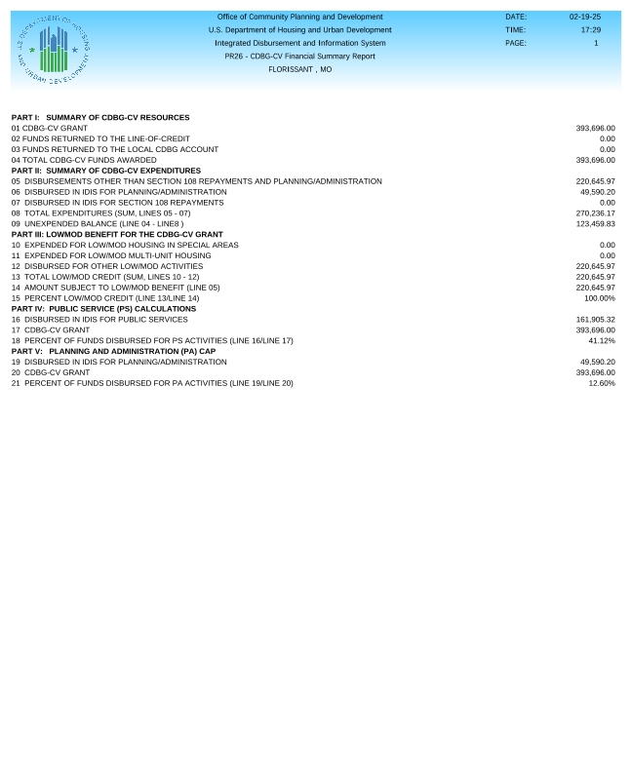

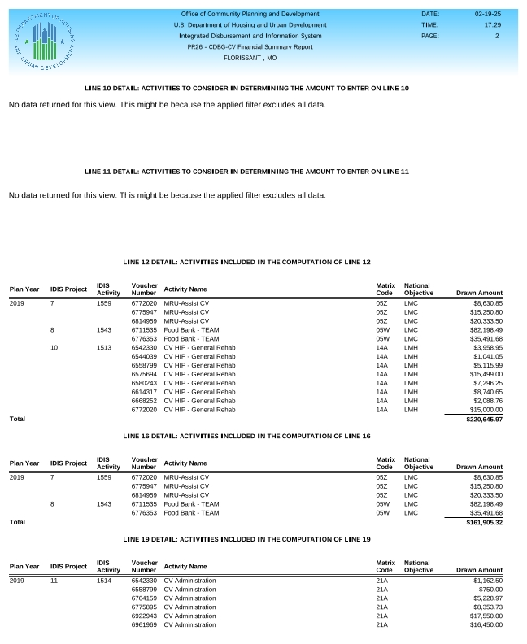

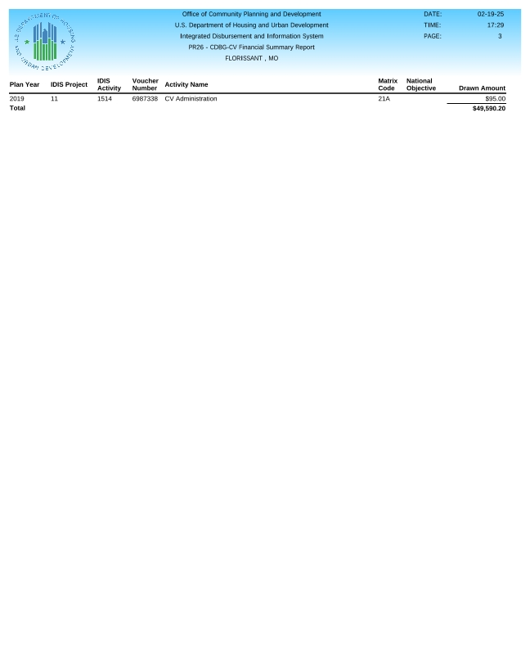

**CDBG PR 26 Report**

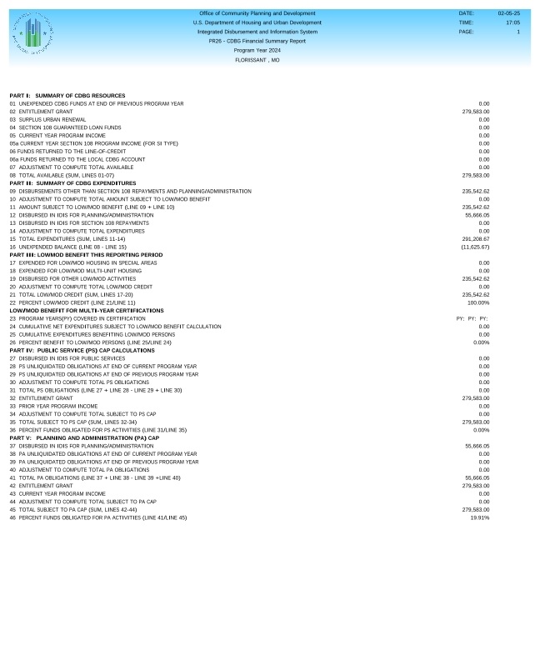

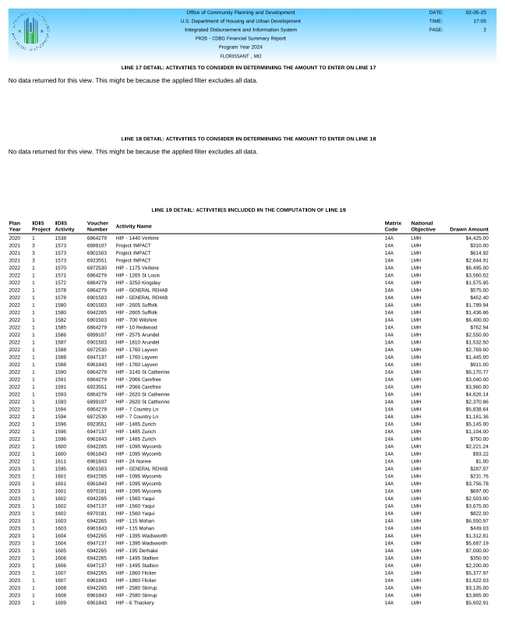

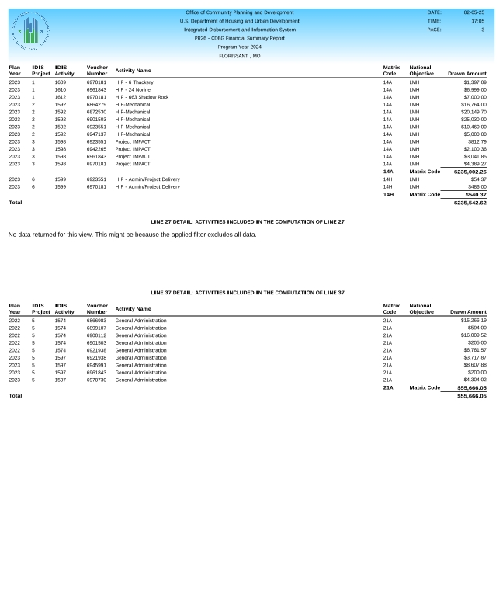

**CAPER Public Notice Documentation**

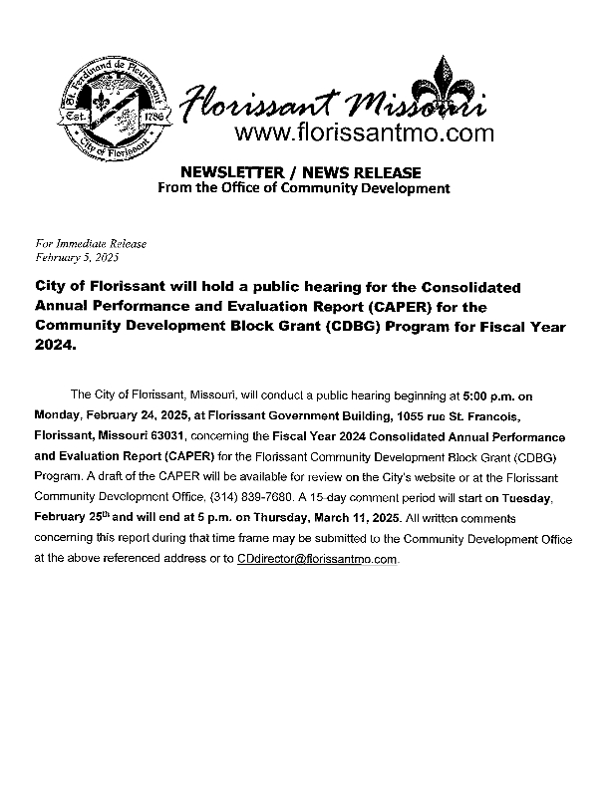

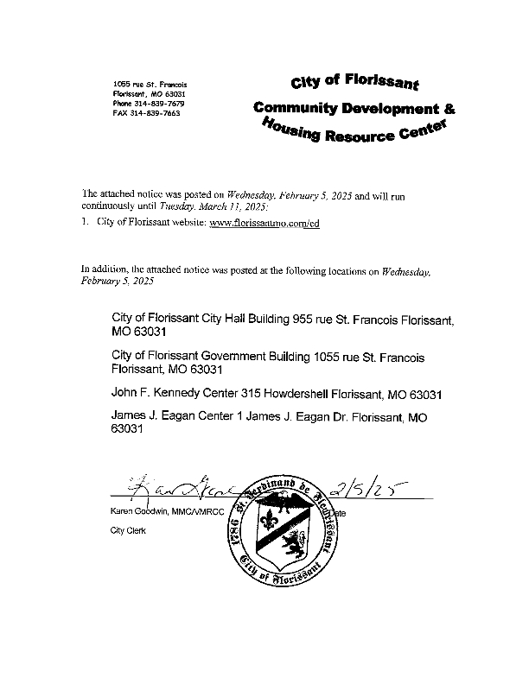

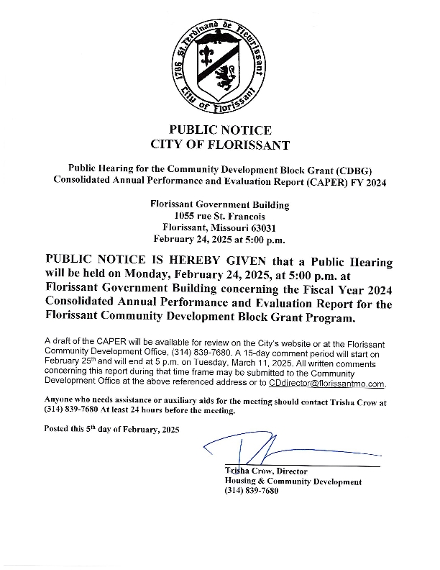

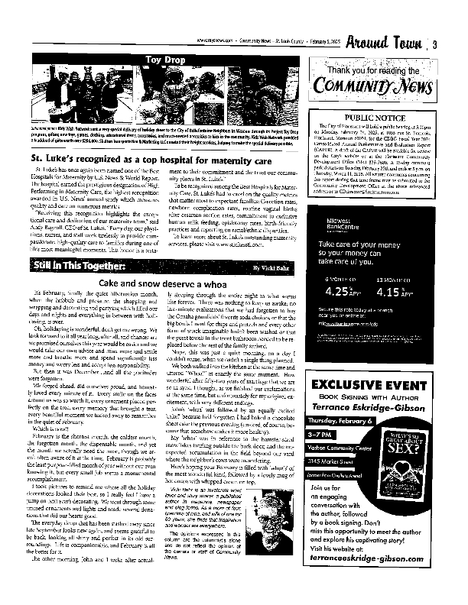

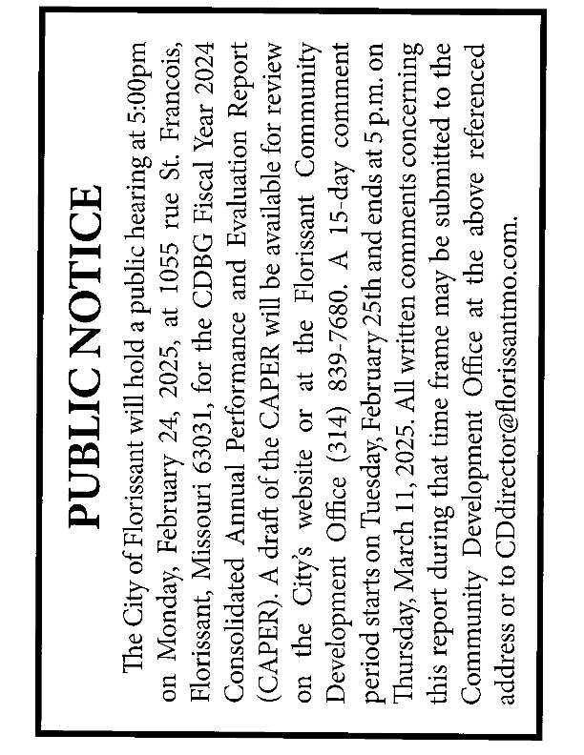

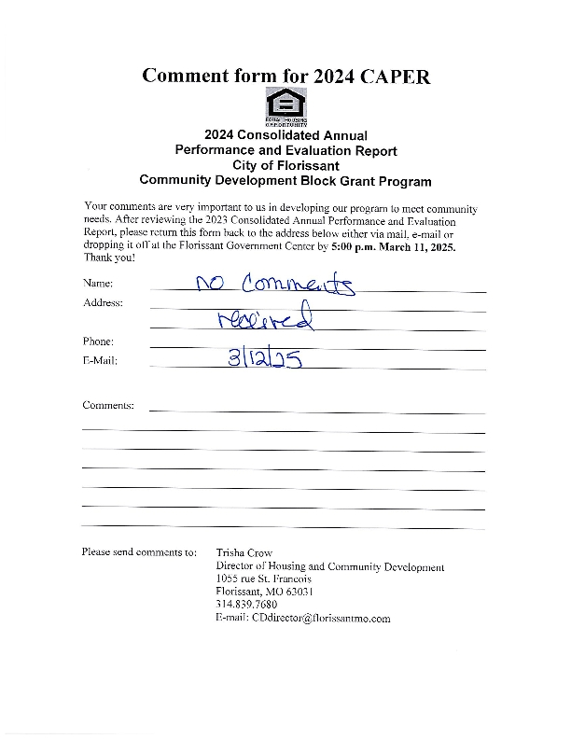

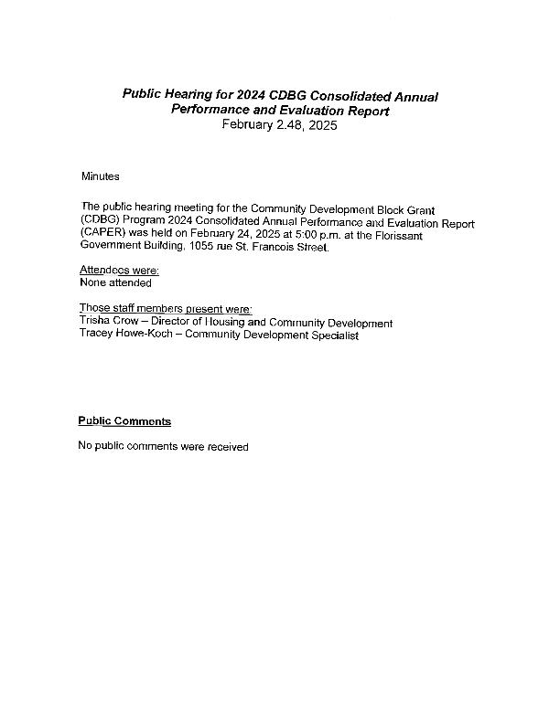

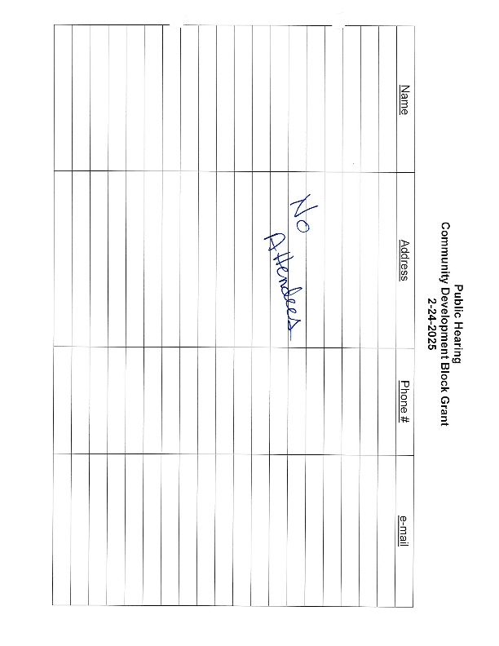

**AAP Public Notice Documentation**

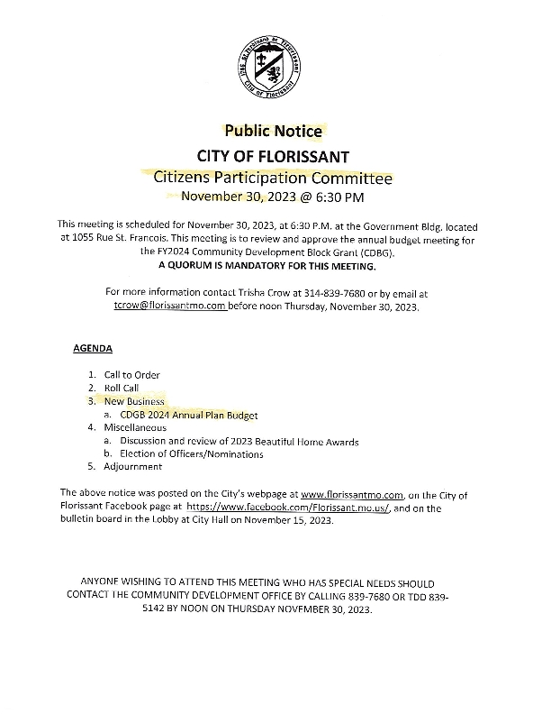

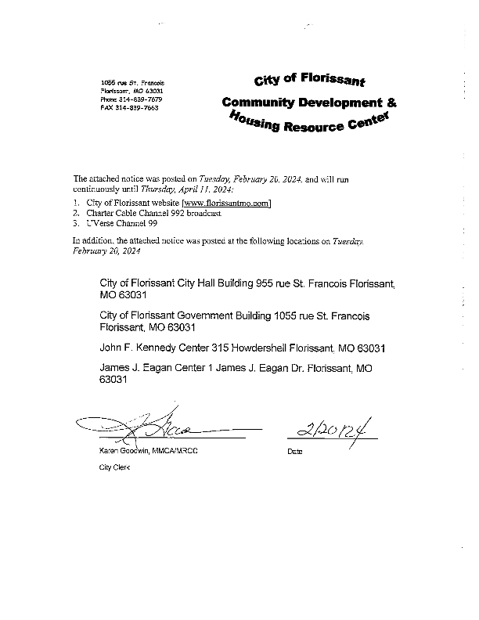

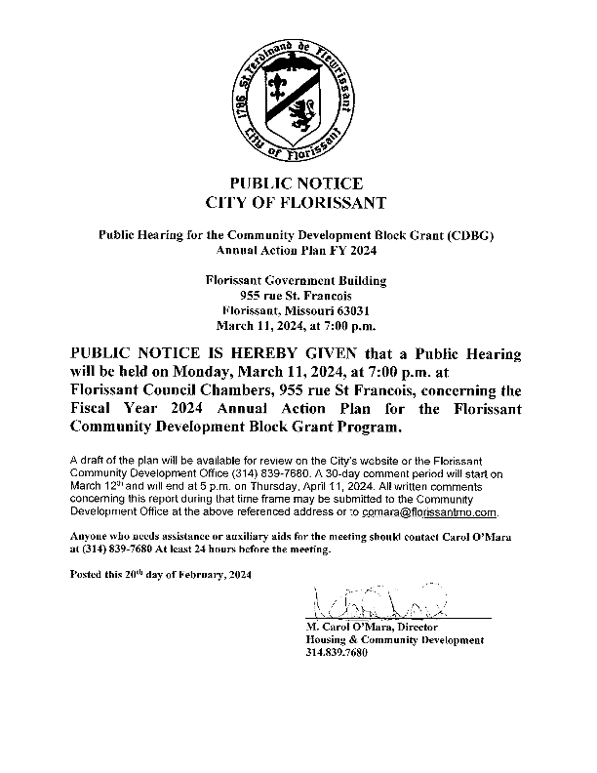

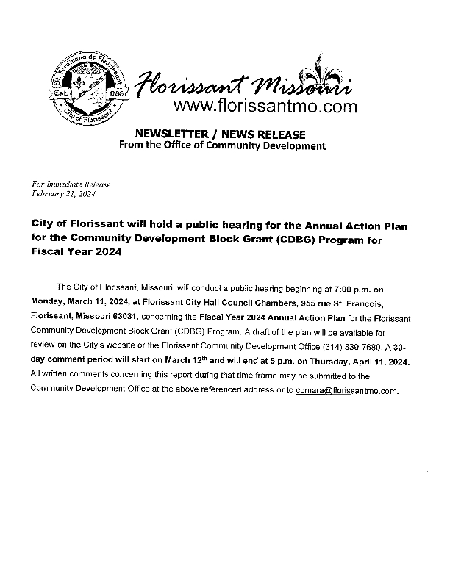

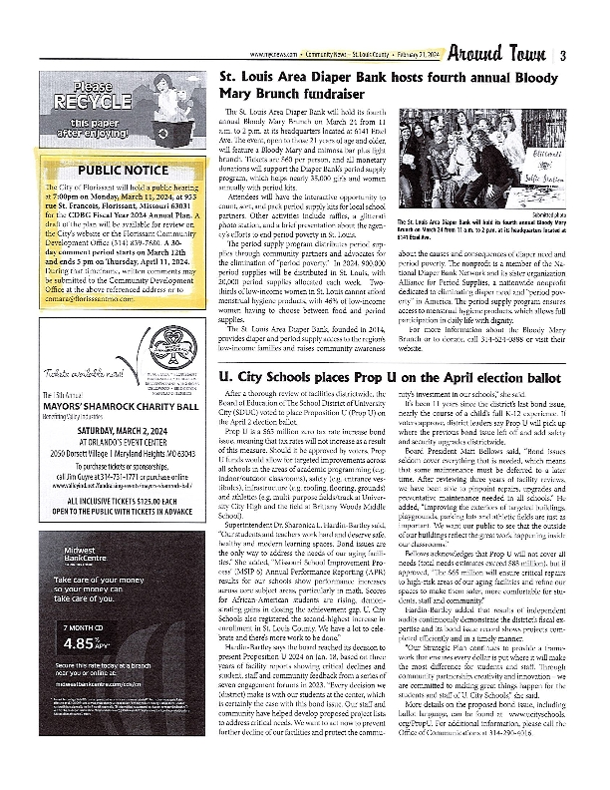

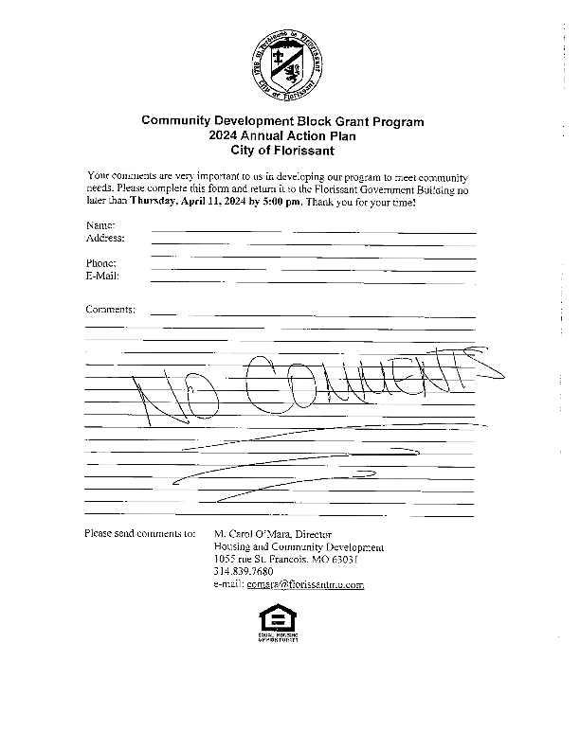

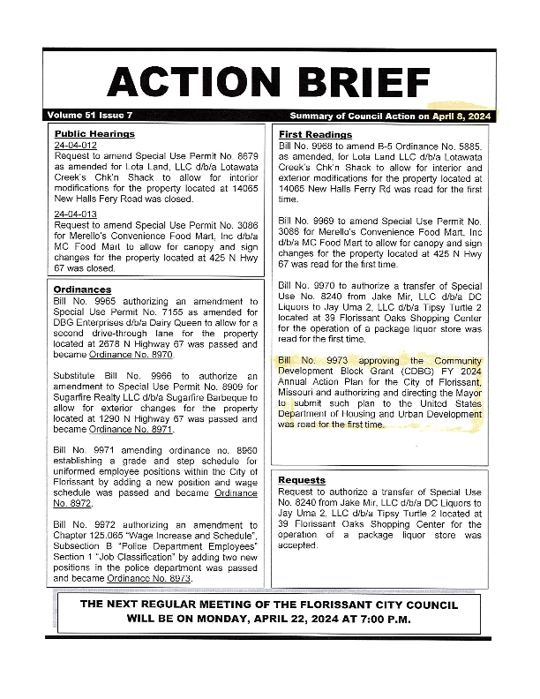

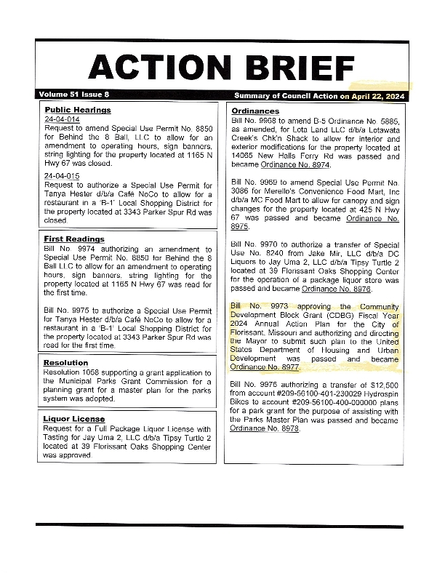

**SF424**

