Executive Summary

ES-05 Executive Summary – 24 CFR 91.200(c), 91.220(b)
1. Introduction
The Consolidated Plan is a strategic planning instrument required by the Department of Housing and Urban Development (HUD) as part of the Community Development Block Grant (CDBG) Program. The Consolidated Plan helps the City of Florissant identify key community issues and the resources to deal with those issues.
This Consolidated Plan outlines the use of Community Development Block Grant (CDBG) funds for FY2021 through FY2025. This document will serve as a five-year Consolidated Plan.
This document also includes the required FY2021 Annual Action Plan. The Annual Action Plan process requires that the grantee outline an action plan, which addresses the priority needs and local objectives of the community over a one-year period.
2. Summary of the objectives and outcomes identified in the Plan Needs Assessment Overview
As an entitlement community, the City of Florissant has determined, through a need’s assessment, market analysis, and public participation process that it is in the best interest of the community to continue to concentrate limited CBDG funds in a few areas of primary concern over the next five years. Housing, Public Services, and the Removal of Architectural Barriers have been the focus in the past and will remain the focus over the next five years. There continues to be a need and concern regarding the preservation and maintenance of existing structures, homeownership, lead, and emergency repair throughout the City. The programs addressing these issues that the City currently funds have been very popular and have met a great need in the community. In addition, Public Services programs such as programs for emergency mortgage, rental, and utility assistance have been identified through the needs assessment and public participation process as important strategies for serving City residents.
3. Evaluation of past performance
The City of Florissant has an excellent performance record and, as of the end of 2020, is on track to meet or exceed performance goals for four out of the five CDBG funded activities from the last Consolidated Plan (covering FY2016-FY2020). Currently, the only one of the five CDBG funded activities from the last Consolidated Plan that has not met the estimated goal is the MRU Assist program. The MRU Assist program was a new program that was created in 2016 to meet a need for rental assistance but some time to get it off the ground. The program is relatively new for the City, and the first year of any new program can be difficult. In other words, not meeting the goal for the MRU Assist program is an issue of ambitious goal-setting in the first year it was offered rather than an issue of poor performance.
4. Summary of citizen participation process and consultation process
The City of Florissant has had an active Citizens Participation Committee (CPC) for many years. It is made up of Florissant residents who are appointed from their respective wards by the City Council. It serves as the official citizen advisory body for all phases of the Community Development Block Grant (CDBG) application development, program implementation, monitoring and evaluation processes. The CPC meets to review CDBG activities and to propose an annual CDBG budget to the City Council.
In accordance with our Citizen Participation Plan, our 2021—2025 Consolidated Plan and 2021 Annual Action Plan process included a public hearing. The CPC committee met and a public hearing was held on May 10, 2021 at 7:00 p.m. via the Zoom platform. Public hearing notices were posted on the City’s cable television channel and the City’s website, soliciting comments and participation in the process. Other announcements were posted across the city at community centers, City Hall, and the Independent Newspaper.
A summary of the draft plan was posted on our website and all of our other media outlets. The summary described the contents of the plan and the entire Consolidated Plan could be reviewed on line and at the City’s Government Center or by written request. The plan was available for public comment for 30 days starting on May 10, 2021. The city also provides free copies of the plan to citizens and groups that request a copy in writing. The draft-consolidated plan is made available to persons with disabilities in a format that is readily accessible upon request.
5. Summary of public comments
At this point in time, there have been no public comments beyond the discussion at the May 10, 2021 Public Hearing and Citizen Participation Committee meeting. Discussion of the 5-year consolidated plan and data at that meeting revealed that the City’s priority need is still single-family housing but with the continued increase in rental dwelling there is a need in this area that is currently going unmet. In response to this unmet need, the City of Florissant will continue to fund the Mortgage, Rental and Utility Assistance Program for FY2021. The funding of this program could assist in possibly opening up more opportunities for Florissant residents.
6. Summary of comments or views not accepted and the reasons for not accepting them
Not Applicable

7. Summary
After a need’s assessment market analysis and public participation process the City of Florissant identified four main goals for 2021-2025. The four main goals include Home Improvement, Home Improvement Program-Mechanical, Project I.M.P.A.C.T., and Mortgage Rental and Utility Assistance.
The Process

PR-05 Lead & Responsible Agencies - 91.200(b)
1. Describe agency/entity responsible for preparing the Consolidated Plan and those responsible for administration of each grant program and funding source
The following are the agencies/entities responsible for preparing the Consolidated Plan and those responsible for administration of each grant program and funding source.
Agency Role | Name | Department/Agency

CDBG Administrator | FLORISSANT | Community Development Department
Table 1– Responsible Agencies

Narrative
The City of Florissant has always been proactive in its communications with residents and we have many mechanisms for public input in place. We publish and mail a quarterly newsletter directly to residents. We also produce our own cable television channel. We have had an active Citizens Participation Committee (CPC) for many years. It was developed as part of the City of Florissant's effort to include as many citizens as possible in the community development planning process. The CPC is made up of Florissant residents who are appointed from their respective wards by the City Council. It serves as the official citizen advisory body for all phases of the Community Development Block Grant (CDBG) application development, program implementation, monitoring and evaluation processes. The CPC is the major mechanism whereby the citizens of Florissant have an opportunity to express their needs as well as to be kept aware of the performance of the city’s community development programs.
The CPC meets to review CDBG activities and to propose an annual CDBG budget to the City Council. It:
- Conducts regular meetings on the second Thursday of each month, except June, July and August
- Evaluates and recommends priorities regarding community development needs
- Evaluates existing CDBG programs
- Evaluates and recommends programs for possible inclusion in future Annual Plans
- Evaluates any amendments to approved CDBG projects, except those for urgent need activities
- Evaluates suggested uses of any CDBG funds earmarked for contingency activities
- The CPC may recommend against such expenditures.
- Reviews the draft Consolidated Plan prior to its being made available for public comment
- Recommends changes in the draft Consolidated Plan.
- Reviews the Citizen Participation Plan annually
- Provides assistance and information to interested individuals and/or groups within Florissant
As a Metropolitan City entitlement community, our goal is to educate the community on the Community Development Block Grant (CDBG) program and to encourage citizen participation in the local consolidated planning process. Our long-term goal is to keep the public involved in our community and to provide opportunities to participate in the consolidated planning process on an annual basis.
In accordance with our Citizen Participation Plan, our process included a public hearing. The CPC committee met and a public hearing for the FY2021—2025 Consolidated Plan was held on May 10, 2021 at 7:00 p.m. via the ZOOM platform. Public hearing notices were posted on the City’s cable television channel and the City’s website, soliciting comments and participation in the process. Other announcements were posted across the city at community centers, City Hall, and in the Independent Newspaper.
A summary of the draft plan was posted on our website, cable TV channel and social media sites. The summary described the contents of the plan and the entire Consolidated Plan could be reviewed on line, at the City’s Government Center or by written request. The plan was available for public comment for 30 days starting on May 10, 2021. The city also provides free copies of the plan to citizens and groups that request a copy in writing. The draft-consolidated plan is made available to persons with disabilities in a format that is readily accessible upon request.
Consolidated Plan Public Contact Information
Mrs. M. Carol O’Mara
Director of Housing and Community Development
Florissant Government Building
1055 rue St. Francois
Florissant, Missouri 63031
(314) 839-7680

PR-10 Consultation - 91.100, 91.110, 91.200(b), 91.300(b), 91.215(l) and 91.315(l)
1. Introduction
The City of Florissant collaborates with a vast network of area nonprofit organizations to utilize their experience and expertise in the areas of housing, homelessness, and identifying met and unmet needs in the city and St. Louis County community. Through the participation and partnerships with Nonprofits that serve the City’s aging community, residents with disabilities, as well as health, employment and wellness-based organizations serving the city’s LMI residents, city staff has learned and identified needs, service gaps and areas for improvement, while also identifying what organizations are already serving the community well. These aspects are important when it comes to identifying city and CDBG allocation goals and priorities.
Provide a concise summary of the jurisdiction’s activities to enhance coordination between public and assisted housing providers and private and governmental health, mental health and service agencies (91.215(I)).
The City of Florissant’s Housing & Community Development Office works closely with area nonprofits that serve those in the community in need of housing. The City has a relationship with the Community Action Agency of St Louis County that delivers a variety of social service programs to low-income elderly, youth, individuals with disabilities and LMI individuals and families through grants and contractual agreements with federal, state, county and local governments, other not-for-profit organizations, and private businesses. They also administer the city’s Mortgage Rent and Utility Assistance Program.
There is currently no Public Housing Authority or Public Housing Developments in the City of Florissant. However, the St Louis County Housing Authority has and continues to administer the Housing Choice Voucher (formerly called Section 8) Program for all of St Louis County where Florissant is located. The waiting list for vouchers is seldom open, but communication is shared quickly and effectively when it is open for application.
Aging Ahead is the Area Agency on Aging that serves the city’s population aged sixty plus. The serve the community in several ways, including but not limited to operating senior centers, providing home delivered meals, in-home services, respite care, and information and assistance. The City of Florissant senior center staff are available by phone and email to assist Florissant senior residents in need of resources, guidance, reassurance, and support with the goal of keeping the aging resident living safely and independently in their own homes.

Describe coordination with the Continuum of Care and efforts to address the needs of homeless persons (particularly chronically homeless individuals and families, families with children, veterans, and unaccompanied youth) and persons at risk of homelessness
The City of Florissant relies on data provided by the COC to institute programs aimed at eradicating homelessness in the area and assisting those who are currently homeless in the community. The City consults with the COC regarding future plans, reporting, and identifying needs in the community, especially as it relates to homelessness. The City of Florissant does not directly offer any shelters or beds for individuals or families who have lost their homes, but the City does offer a Mortgage, Rent & Utility Assistance program to our residents, and plan to continue to do so through CDBG funding and CDBG- CV (CARES ACT) funding. This program will provide funds to one or more social service agencies to help people on the verge of homelessness.
Describe consultation with the Continuum(s) of Care that serves the jurisdiction's area in determining how to allocate ESG funds, develop performance standards and evaluate outcomes, and develop funding, policies and procedures for the administration of HMIS
The City of Florissant does not receive ESG funds from HUD

2. Describe Agencies, groups, organizations and others who participated in the process and describe the jurisdictions consultations with housing, social service agencies and other entities
Table 2– Agencies, groups, organizations who participated
1 | Agency/Group/Organization | Citizen Participation Committee
 | Agency/Group/Organization Type | Civic Leaders
 | What section of the Plan was addressed by Consultation? | Housing Need Assessment  Market Analysis
 | How was the Agency/Group/Organization consulted and what are the anticipated outcomes of the consultation or areas for improved coordination? | The City of Florissant has had an active Citizens Participation Committee (CPC) for many years. It is made up of Florissant residents who are appointed from their respective wards by the City Council. It serves as the official citizen advisory body for all phases of the Community Development Block Grant (CDBG) application development, program implementation, monitoring and evaluation processes. The CPC meets to review CDBG activities and to propose an annual CDBG budget to the City Council. In accordance with our Citizen Participation Plan, our 2021-2025 Consolidated Plan and 2021 Annual Action Plan process included a public hearing. The CPC committee met and a public hearing was held on May 10, 2021 at 7:00 p.m. via the ZOOM platform. Public hearing notices were posted on the City website, cable television channel and social media sites, soliciting comments and participation in the process.

Identify any Agency Types not consulted and provide rationale for not consulting
The City of Florissant aims to consult with as many agencies as possible and did not exclude any agencies or agency types from consultation

Other local/regional/state/federal planning efforts considered when preparing the Plan
Name of Plan | Lead Organization | How do the goals of your Strategic Plan overlap with the goals of each plan?
Continuum of Care |  | The Continuum of Care (COC) provides networking opportunities for area agencies to gather to discuss the state of the community regarding their clients, programs, and assistance and leads the charge to end homelessness. Florissant networks with Continuum agencies to provide assistance in reaching their goals to assist those in need within the community.
Table 3– Other local / regional / federal planning efforts

Describe cooperation and coordination with other public entities, including the State and any adjacent units of general local government, in the implementation of the Consolidated Plan (91.215(l))
The City of Florissant coordinates with various St. Louis County departments and is a member of the St. Louis County Housing Consortium.
Narrative

PR-15 Citizen Participation - 91.105, 91.115, 91.200(c) and 91.300(c)
1. Summary of citizen participation process/Efforts made to broaden citizen participation
Summarize citizen participation process and how it impacted goal-setting
The City of Florissant has had an active Citizens Participation Committee (CPC) for many years. It is made up of Florissant residents who are appointed from their respective wards by the City Council. It serves as the official citizen advisory body for all phases of the Community Development Block Grant (CDBG) application development, program implementation, monitoring and evaluation processes. The CPC meets to review CDBG activities and to propose an annual CDBG budget to the City Council.
In accordance with our Citizen Participation Plan, our 2021—2025 Consolidated Plan and 2021 Annual Action Plan process included a public hearing. The CPC committee met and a public hearing was held on May 10, 2021 at 7:00 p.m. via the ZOOM platform. Public hearing notices were posted on the City’s cable television channel and the City’s website, and social media sites soliciting comments and participation in the process. Other announcements were posted across the city at community centers, City Hall, and in the Independent Newspaper.
A summary of the draft plan was posted on our website, cable TV channel and social media sites. The summary described the contents of the plan and the entire Consolidated Plan could be reviewed on line, at the City’s Government Center or by written request. The plan was available for public comment for 30 days starting on May 10, 2021. The city also provides free copies of the plan to citizens and groups that request a copy in writing. The draft-consolidated plan is made available to persons with disabilities in a format that is readily accessible upon request.
At this point in time, there have been no public comments beyond the discussion at the May 10, 2021 Public Hearing and Citizen Participation Committee meeting. Discussion revealed that the City’s priority need is still single-family housing but with the continued increase in rental dwelling there is a need in this area that is currently going unmet. In response to this unmet need, the City of Florissant will continue to fund the Mortgage, Rental and Utility Assistance Program for FY2021. The funding of this program could assist in possibly opening up more opportunities for Florissant residents.
Citizen Participation Outreach
Sort Order | Mode of Outreach | Target of Outreach | Summary of  response/attendance | Summary of  comments received | Summary of comments not accepted and reasons | URL (If applicable)
1 | Public Hearing | Non-targeted/broad community | In accordance with our Citizen Participation Plan, our 2021-2025 Consolidated Plan and 2021 Annual Action Plan process included a public hearing. The Citizen Participation Plan committee met and a public hearing was held on May 10, 2021 at 7:00 p.m. via the ZOOM platform. Public hearing notices were posted on the City's cable television channel, the City's website and social media sites, soliciting comments and participation in the process. Other announcements were posted across the city at community centers, City Hall, and in the Independent Newspaper. | No comments received
2 | Newspaper Ad | Non-targeted/broad community | In accordance with our Citizen Participation Plan, our 2021-2025 Consolidated Plan and 2021 Annual Action Plan process included a public hearing. The CPC committee met and a public hearing was held on May 10, 2021 at 7:00 p.m. via the ZOOM platform. Public hearing notices were posted on the City's cable television channel, the City's website and social media sites, soliciting comments and participation in the process. Other announcements were posted across the city at community centers, City Hall, and in the Independent Newspaper. | No comments received
3 | Cable Television | Non-targeted/broad community | A summary of the draft plan was posted on our cable TV channel. The summary described the contents of the plan and the entire Consolidated Plan could be reviewed on line, at the City Government Center or by written request. | No comments received
Table 4– Citizen Participation Outreach

Needs Assessment

NA-05 Overview
Needs Assessment Overview
As of the 2019 American Community Survey, Florissant was home to 50,952 people, a rate of -2.3% since 2010. The majority of the population was White (52.1% as of 2019) and almost half was Black/African American (40.1% as of 2019). No other minority group made up more than 4% of the City’s population. Median household income in Florissant ($54,978) was slightly lower than that of the State of Missouri ($55,461) according to the 2019 American Community Survey.
Florissant had an unemployment rate of approximately 8.6% prior to the Covid-19 recession. As the economy reopens, it could be estimated that the economy of Florissant will return to a similar level.
Like in many other communities throughout the St. Louis region, some households in the City of Florissant are housing cost burdened. HUD considers a household housing cost burdened if their rent or home ownership costs exceeds 30% of their household income. In Florissant, 48.2% of renter households and 18.5% of owner households face housing cost burden.
The development of the City’s land is now almost complete and the major issues facing the City are a mature housing stock, and aging population, and a changing economic environment. Yet Florissant remains a viable, prosperous community of opportunity that offers its residents a variety of services and activities.

NA-50 Non-Housing Community Development Needs - 91.415, 91.215 (f)
Describe the jurisdiction’s need for Public Facilities:
The City of Florissant does not intend to use its limited CDBG funding for public facilities within the next five years. Public facilities needs within the City of Florissant are determined by the Department of Public Works, which utilizes City funding and other competitive grants to complete high priority projects.
How were these needs determined?
Public facilities needs within the City of Florissant are determined by the Department of Public Works, which utilizes City funding and other competitive grants to complete high priority projects.
Describe the jurisdiction’s need for Public Improvements:
The City of Florissant does not intend to use its limited CDBG funding for public improvements within the next five years. Public improvements needs within the City of Florissant are determined by the Department of Public Works, which utilizes City funding and other competitive grants to complete high priority projects.
How were these needs determined?
Public improvements needs within the City of Florissant are determined by the Department of Public Works, which utilizes City funding and other competitive grants to complete high priority projects.
Describe the jurisdiction’s need for Public Services:
High priority public services needs were determined during the Consolidated Plan process through a needs assessment, market analysis, and discussions with community stakeholders via a public hearing and Citizens Participation Committee (CPC) meeting High priority public service needs include services for persons with disabilities in Florissant (based on American Community Survey data, approximately 5,248 persons under the age of 65 in Florissant have a disability) and emergency mortgage, rental, and utility assistance (especially given that there are approximately 4,590 renter households who cannot benefit from the other home repair-focused programs conducted through the CDBG program). The emergency mortgage, rental, and utility assistance program has been provided by the City of Florissant in past years and proved to be a valuable public service to the community.
How were these needs determined?
High priority public services needs were determined during the Consolidated Plan process through a needs assessment, market analysis, and discussions with community stakeholders via a public hearing and Citizens Participation Committee (CPC) meeting.
Based on the needs analysis above, describe the State's needs in Colonias

Housing Market Analysis

MA-05 Overview
Housing Market Analysis Overview:
The City of Florissant remains an attractive and desirable place to live, with a relatively strong housing market despite the recent foreclosure crisis that affected much of North St. Louis County, the St. Louis region, and the nation as a whole. According to the 2019 American Community Survey 5-Year estimates, Florissant contains a total of 19,710 housing units, of which the majority are single-family detached units (78.4%). The homeownership rate was 65.2%. Vacancy rates in the City were roughly equivalent for ownership units (2.5%) than for rental units (2.8%). The vast majority of Florissant’s housing stock was built between 1950 and 1979. The overall quality of housing in Florissant is good, which is attributable in part to the City’s residential code enforcement efforts. The success of the City’s occupancy permit process and code enforcement efforts means that many homes 30 to 50 years old are in good condition.
However, despite the strength of the City of Florissant’s housing stock, housing markets are affected by a variety of large-scale trends. When the City of Florissant is viewed within a regional context, it is clear that maintaining the stability of the current housing market and property values will be just as important as providing affordable housing options over the next five years, which points to a strategy focused on maintaining and rehabilitating existing housing units.

MA-45 Non-Housing Community Development Assets - 91.410, 91.210(f)
Introduction

Economic Development Market Analysis
Business Activity
Business by Sector | Number of Workers | Number of Jobs | Share of Workers  % | Share of Jobs  % | Jobs less workers  %
Agriculture, Mining, Oil & Gas Extraction | 51 | 0 | 0 | 0 | 0
Arts, Entertainment, Accommodations | 2,236 | 2,843 | 9 | 22 | 13
Construction | 1,068 | 285 | 4 | 2 | -2
Education and Health Care Services | 6,142 | 4,158 | 25 | 32 | 7
Finance, Insurance, and Real Estate | 1,749 | 433 | 7 | 3 | -4
Information | 638 | 132 | 3 | 1 | -2
Manufacturing | 3,450 | 54 | 14 | 0 | -14
Other Services | 1,549 | 424 | 6 | 3 | -3
Professional, Scientific, Management Services | 2,380 | 322 | 10 | 2 | -8
Public Administration | 890 | 306 | 4 | 2 | -2
Retail Trade | 2,728 | 3,529 | 11 | 27 | 16
Transportation and Warehousing | 1,571 | 320 | 6 | 2 | -4
Wholesale Trade | 569 | 109 | 2 | 1 | -1
Total | 25,021 | 12,915 | -- | -- | --
Table 5 - Business Activity

Alternate Data Source Name:
Census 2010
Data Source Comments: | 2019 ACS (Workers), 2018 Longitudinal Employer-Household Dynamics (Jobs)
Labor Force
Total Population in the Civilian Labor Force | 27,366
Civilian Employed Population 16 years and over | 25,021
Unemployment Rate | 8.60
Unemployment Rate for Ages 16-24 | 0.00
Unemployment Rate for Ages 25-65 | 0.00
Table 6 - Labor Force

Data Source Comments: | 2019 ACS

Occupations by Sector | Number of People
Management, business and financial | 7,998
Farming, fisheries and forestry occupations | 0
Service | 4,830
Sales and office | 6,165
Construction, extraction, maintenance and repair | 1,765
Production, transportation and material moving | 4,263
Table 7 – Occupations by Sector

Data Source Comments: | 2019 ACS

Travel Time
Travel Time | Number | Percentage
< 30 Minutes | 16,456 | 64%
30-59 Minutes | 8,122 | 32%
60 or More Minutes | 963 | 4%
Total | 25,541 | 100%
Table 8 - Travel Time

Data Source Comments: | 2019 ACS

Education:
Educational Attainment by Employment Status (Population 16 and Older)
Educational Attainment | In Labor Force
 | Civilian Employed | Unemployed | Not in Labor Force
Less than high school graduate | 1,170 | 61 | 461
High school graduate (includes equivalency) | 6,061 | 602 | 1,297
Some college or Associate's degree | 9,190 | 576 | 1,638
Bachelor's degree or higher | 5,216 | 266 | 590
Table 9 - Educational Attainment by Employment Status

Data Source Comments: | 2007-2011 ACS

Educational Attainment by Age
 | Age
 | 18–24 yrs | 25–34 yrs | 35–44 yrs | 45–65 yrs | 65+ yrs
Less than 9th grade | 0 | 32 | 37 | 222 | 891
9th to 12th grade, no diploma | 895 | 348 | 460 | 593 | 1,034
High school graduate, GED, or alternative | 1,540 | 1,376 | 2,134 | 4,450 | 3,363
Some college, no degree | 1,631 | 2,086 | 1,975 | 4,214 | 1,580
Associate's degree | 498 | 930 | 1,044 | 1,194 | 286
Bachelor's degree | 431 | 1,378 | 962 | 2,168 | 691
Graduate or professional degree | 15 | 455 | 264 | 845 | 289
Table 10 - Educational Attainment by Age

Data Source Comments: | 2007-2011 ACS

Educational Attainment – Median Earnings in the Past 12 Months
Educational Attainment | Median Earnings in the Past 12 Months
Less than high school graduate | 22,218
High school graduate (includes equivalency) | 31,929
Some college or Associate's degree | 34,538
Bachelor's degree | 41,634
Graduate or professional degree | 49,476
Table 11 – Median Earnings in the Past 12 Months

Data Source Comments: | 2007-2011 ACS

Based on the Business Activity table above, what are the major employment sectors within your jurisdiction?
Major employment sectors include Arts, Entertainment, and Accommodations; Education and Health Care Services; and Retail Trade.
Describe the workforce and infrastructure needs of the business community:
While increased workforce development is always important, the City of Florissant adequately meets the needs of the business community. Florissant is well-located, with highway I-270, one of several interstate highways connecting the St. Louis region, passing through Florissant’s southern edge. Metro public transit includes a fleet of busses, light rail and paratransit vehicles that serve Florissant and other parts of St. Louis County. Florissant is served by the Ferguson-Florissant and Hazelwood school districts, both of which had graduate rates in line with the state rate as of the 2018 school year.
Describe any major changes that may have an economic impact, such as planned local or regional public or private sector investments or initiatives that have affected or may affect job and business growth opportunities during the planning period. Describe any needs for workforce development, business support or infrastructure these changes may create.
One major initiative that may affect business growth within the region (and thus also, possibly, within Florissant) has been the formation of Greater St. Louis Inc. Greater St. Louis, Inc, a merger of 4 preexisting development agencies, brings together business and civic leaders to create jobs, expand inclusive economic growth and improve St. Louis’ global competitiveness. The organization is dedicated to St. Louis’ growth and prosperity as a global metropolitan region that expands economic opportunity for all.
How do the skills and education of the current workforce correspond to employment opportunities in the jurisdiction?
Workforce training initiatives are offered through the St. Louis County Department of Human Services Division of Workforce Development through Career Centers. The mission of the Career Centers is to serve as a partnership between Saint Louis County residents and businesses in supporting the Saint Louis Metropolitan area's economic development with a qualified workforce. While the services offered are designed to serve the entire population of St. Louis County, one of the two Career Centers is located very close to the City of Florissant and is easily accessible to residents. T Center is open Monday-Friday and located at 4040 Seven Hills Drive, Suite 166, St. Louis, MO, 63033-6770. The Career Center offers a broad range of services, including workshops on topics such as computer skills, budgeting, networking, resume writing, and career resources for Veterans.
Describe any current workforce training initiatives, including those supported by Workforce Investment Boards, community colleges and other organizations. Describe how these efforts will support the jurisdiction's Consolidated Plan.
Workforce training initiatives are offered through the St. Louis County Department of Human Services Division of Workforce Development through Career Centers. The mission of the Career Centers is to serve as a partnership between Saint Louis County residents and businesses in supporting the Saint Louis Metropolitan area's economic development with a qualified workforce. While the services offered are designed to serve the entire population of St. Louis County, one of the two Career Centers is located very close to the City of Florissant and is easily accessible to residents. T Center is open Monday-Friday and located at 4040 Seven Hills Drive, Suite 166, St. Louis, MO, 63033-6770. The Career Center offers a broad range of services, including workshops on topics such as computer skills, budgeting, networking, resume writing, and career resources for Veterans.
Does your jurisdiction participate in a Comprehensive Economic Development Strategy (CEDS)?
No
If so, what economic development initiatives are you undertaking that may be coordinated with the Consolidated Plan? If not, describe other local/regional plans or initiatives that impact economic growth.
Greater St. Louis Inc, referenced above, has a strategic plan. City of Florissant staff will keep up to date on the plan’s progress and how it might connect to Consolidated Plan activities. Strategic Plan focus areas for Greater St. Louis Inc include:
- Stewarding an inclusive economy.
- Restoring the core of St. Louis
- Investing in competitive industries
- Becoming a talent engine & magnet
- Building a world-class small business & entrepreneurial ecosystem
Discussion

MA-50 Needs and Market Analysis Discussion
Are there areas where households with multiple housing problems are concentrated? (include a definition of "concentration")
Housing needs are not highly concentrated geographically, but rather exist throughout the City of Florissant, as low- to moderate-income households are distributed throughout the City of Florissant.
Are there any areas in the jurisdiction where racial or ethnic minorities or low-income families are concentrated? (include a definition of "concentration")
City of Florissant, but are especially concentrated in areas where rental housing options are available. Public services programs that meet the needs of renter households, such as emergency rental and/or utility assistance, are important to serving persons residing in the pockets of the City where renter-occupied units are more common. Public services spending, however, is limited and restricted to a maximum of 15% of a Participating Jurisdiction’s CDBG allocation.
What are the characteristics of the market in these areas/neighborhoods?
As shown in Section MA-05 of this document, the housing market conditions within the City of Florissant are relatively consistent, especially when compared to St. Louis County as a whole.
Are there any community assets in these areas/neighborhoods?
As described above, there is no single area within Florissant where low- and moderate-income or minority populations are concentrated. Rather, needs exist throughout the jurisdiction. In terms of assets, the City of Florissant is a viable, prosperous community that offers its residents a variety of services and activities. Assets include the James J. Eagan and John F. Kennedy Recreation Centers, the James J. Eagan Center Ice Rink, the Florissant Civic Center Theatre, the Florissant Valley Branch of the St. Louis Public Library, and a multitude of businesses, services, and churches. In terms of opportunities, the City of Florissant does not receive a large enough CDBG allocation to catalyze large-scale housing development. Additionally, development of the City’s land is now almost complete and the major issues facing the City are a mature housing stock, and aging population, and a changing economic environment.
Are there other strategic opportunities in any of these areas?
As described above, there is no single area within Florissant where low- and moderate-income or minority populations are concentrated. Rather, needs exist throughout the jurisdiction. In terms of assets, the City of Florissant is a viable, prosperous community that offers its residents a variety of services and activities. Assets include the James J. Eagan and John F. Kennedy Recreation Centers, the James J. Eagan Center Ice Rink, the Florissant Civic Center Theatre, the Florissant Valley Branch of the St. Louis Public Library, and a multitude of businesses, services, and churches. In terms of opportunities, the City of Florissant does not receive a large enough CDBG allocation to catalyze large-scale housing development. Additionally, development of the City’s land is now almost complete and the major issues facing the City are a mature housing stock, and aging population, and a changing economic environment.
MA-60 Broadband Needs of Housing occupied by Low- and Moderate-Income Households - 91.210(a)(4), 91.310(a)(2)
Describe the need for broadband wiring and connections for households, including low- and moderate-income households and neighborhoods.
Broadband internet access is the gateway to information, education, employment, opportunity and equality in our world. Equal access to this service is of the utmost importance for all households.
Describe the need for increased competition by having more than one broadband Internet service provider serve the jurisdiction.
Competition between broadband internet providers appears to be one of the only methods, outside of government regulation, of driving down prices so that middle to low income families can afford the service.
MA-65 Hazard Mitigation - 91.210(a)(5), 91.310(a)(3)
Describe the jurisdiction’s increased natural hazard risks associated with climate change.
Emergency Management is the managerial function charged with creating the framework within which communities reduce vulnerability to hazards and cope with disasters. The Police Department has three active Emergency Management personnel. These officers attend numerous trainings throughout the year to better prepare in case a disaster strikes our area. Lieutenant Andy Haarmann acts as the Director of Emergency Management for the City of Florissant. There are clear policies in place to address the rising probability that an earthquake, tornado, flood and/or other natural hazard risk associated with climate change.
Describe the vulnerability to these risks of housing occupied by low- and moderate-income households based on an analysis of data, findings, and methods.
The majority of the homes located in the city limits of Florissant have basements, however, there are some slap homes scattered throughout and there are no high-rise communities. Collaboration with Florissant’s Emergency Management Department, St Louis County's SEMA and FEMA, is imperative to ensuring that the City's LMI population is protected and would have prompt access to services. The City's CDBG Home Repair Programs also work to safeguard homes to possible natural disaster as well as its partnership with area nonprofit organizations who specialize in similar areas.
Strategic Plan

SP-05 Overview
Strategic Plan Overview
This Strategic Plan portion of the Consolidated Plan identifies specific strategies and associated goals to address community needs over the next five years (FY2021-FY2025) that are consistent with the goals and requirements of the CDBG program.
Due to the limited dollar amount of funds available from the CDBG program, the City of Florissant has determined, through a needs assessment, market analysis, and public participation process, that it is in the best interest of the community to continue to concentrate limited CBDG funds in a few areas of primary concern over the next five years. Housing, Public Services, and the Removal of Architectural Barriers have been the focus in the past and will remain the focus over the next five years. There continues to be a need and concern regarding the preservation and maintenance of existing structures, homeownership, lead, and emergency repair throughout the City. The programs addressing these issues that the City currently funds have been very popular and have met a great need in the community. In addition, Public Services programs such as programs for persons with disabilities and emergency mortgage, rental, and utility assistance have been identified through the needs assessment and public participation process as important strategies for serving City residents.

SP-10 Geographic Priorities - 91.415, 91.215(a)(1)
Geographic Area
Table 12 - Geographic Priority Areas
1 | Area Name: | City of Florissant
 | Area Type: | Local Target area
 | Other Target Area Description:
 | HUD Approval Date:
 | % of Low/ Mod:
 | Revital Type: | Housing
 | Other Revital Description:
 | Identify the neighborhood boundaries for this target area.
 | Include specific housing and commercial characteristics of this target area.
 | How did your consultation and citizen participation process help you to identify this neighborhood as a target area?
 | Identify the needs in this target area.
 | What are the opportunities for improvement in this target area?
 | Are there barriers to improvement in this target area?

General Allocation Priorities
Describe the basis for allocating investments geographically within the state
The City of Florissant will not be allocating CDBG funded programs based on geographic target areas. CDBG investments are made city-wide since low- to moderate-income persons are not concentrated in a single geographic area of the City. Instead, programs funds will be distributed based on need and eligibility. It is important to note that other City of Florissant programs not covered by this Consolidated Plan are geographically targeted. For example, the City of Florissant applied for and received a grant from the Neighborhood Stabilization Program (NSP) through the Department of Housing and Urban Development (HUD) Recovery Act funds. The City was awarded $1.5 million dollars for the purchase, rehabilitation, and resale of foreclosed homes in order to stabilize neighborhoods and stem the decline of house values of neighboring homes. The City continues to administer this program through the original award amount and additional Program Income. No other local, state, or federal funds will be utilized for these projects. These NSP projects are geographically targeted to NSP-eligible areas within the City of Florissant.

SP-25 Priority Needs - 91.415, 91.215(a)(2)
Priority Needs
Table 13 – Priority Needs Summary
1 | Priority Need Name | Housing Repair and Improvement
 | Priority Level | High
 | Population | Extremely Low  Low  Moderate  Large Families  Families with Children  Elderly
 | Geographic Areas Affected | City of Florissant
 | Associated Goals | Home Improvement Program  Home Improvement Program - Mechanical  Administration
 | Description | Housing Repair and Improvments for Low-to-Moderate Income Homeowners
 | Basis for Relative Priority | Relative priorities were based on the needs and market analyses, as well as public input from the Citizens Participation Committee.
2 | Priority Need Name | Housing Accessibility
 | Priority Level | High
 | Population | Extremely Low  Low  Moderate  Large Families  Families with Children  Elderly  Elderly  Frail Elderly  Persons with Physical Disabilities
 | Geographic Areas Affected | City of Florissant
 | Associated Goals | Project I.M.P.A.C.T.  Administration
 | Description | Housing Accessibility for Low-to-Moderate Income Homeowners
 | Basis for Relative Priority | Relative priorities were based on the needs and market analyses, as well as public input from the Citizens Participation Committee.
3 | Priority Need Name | Services for Persons with Disabilities
 | Priority Level | High
 | Population | Extremely Low  Low  Moderate  Elderly  Elderly  Frail Elderly  Persons with Mental Disabilities  Persons with Physical Disabilities  Persons with Developmental Disabilities
 | Geographic Areas Affected | City of Florissant
 | Associated Goals | Project I.M.P.A.C.T.  Administration
 | Description | Services for low-to-moderate income persons with disabilities
 | Basis for Relative Priority | Relative priorities were based on the needs and market analyses, as well as public input from the Citizens Participation Committee.
4 | Priority Need Name | Emergency Mortgage, Rental, and Utility Assistance
 | Priority Level | High
 | Population | Extremely Low  Low  Moderate
 | Geographic Areas Affected | City of Florissant
 | Associated Goals | Mortgage, Rent & Utility Assistance  Administration
 | Description | Emergency mortgage, rental, and utility assistance for low- to moderate-income renters and homeowners.
 | Basis for Relative Priority | Relative priorities were based on the needs and market analyses, as well as public input from the Citizens Participation Committee.
Narrative (Optional)

SP-35 Anticipated Resources - 91.420(b), 91.215(a)(4), 91.220(c)(1,2)
Introduction
The City of Florissant expects an allocation of $266,269 in CDBG funding for FY2021. During the FY2016-FY2020 Consolidated Plan period, CDBG allocations varied between $212,059 (lowest allocation) and 257,640 (highest allocation) with an average allocation of $296,579. The chart below assumes that same average allocation of $296,579 for each of the five years FY2021, FY2022, FY2023, FY2024 and FY2025.

Anticipated Resources
Program | Source of Funds | Uses of Funds | Expected Amount Available Year 1 |  |  |  | Expected Amount Available Remainder of ConPlan  $ | Narrative Description
 |  |  | Annual Allocation: $ | Program Income: $ | Prior Year Resources: $ | Total:  $
CDBG | public - federal | Acquisition  Admin and Planning  Economic Development  Housing  Public Improvements  Public Services | 266,269 | 0 | 0 | 266,269 | 1,216,626 | The City of Florissant expects a CDBG allocation of $266,269 for FY2021 and the average allocation of $296,579 for following years.
Table 14 - Anticipated Resources

Explain how federal funds will leverage those additional resources (private, state and local funds), including a description of how matching requirements will be satisfied
While the City of Florissant has a small CDBG allocation, it is very highly leveraged through the Project I.M.P.A.C.T. program in order to provide home repairs and accessibility improvements to the maximum number of low- to moderate-income disabled Florissant residents. The Project I.M.P.A.C.T. program uses CDBG funding to purchase wheelchair ramps, materials and supplies for homes that are then rehabbed by qualified volunteers. The volunteer labor allows more households to be served with limited funding.
If appropriate, describe publically owned land or property located within the state that may be used to address the needs identified in the plan
At the current time, no Identified publicly owned land or property to be sued to address the needs identified in the plan.
Discussion
Over the past decade The City of Florissant has become more effective at stretching CDBG dollars by creating new relationships with donors, volunteers, and other organizations to support the highly leveraged Project I.M.P.A.C.T. program.

SP-40 Institutional Delivery Structure - 91.415, 91.215(k)
Explain the institutional structure through which the jurisdiction will carry out its consolidated plan including private industry, non-profit organizations, and public institutions.
Responsible Entity | Responsible Entity Type | Role | Geographic Area Served
City of Florissant | Government | Economic Development  Ownership  Rental  neighborhood improvements  public facilities  public services | Jurisdiction
Table 15 - Institutional Delivery Structure
Assess of Strengths and Gaps in the Institutional Delivery System
The City of Florissant Department of Housing and Community Development administers the programs funded by the Community Development Block Grant. Private contractors do the actual work of rehabilitation services. The City staff is able to adequately monitor these contractors to assure that services are provided as promised.
The City administers the plans to all but one program funded with CDBG money. This allows staff to have a constant hand in the successfulness of the programs with regards to being responsive and the overall completion of paperwork and projects. Staff follows up with residents participating in the Home Improvement Program and receives top scores and feedback from those who participated. There are not any gaps in the Institutional Delivery System.
The City of Florissant does not administer ESG or HOPWA funding. Improvement of the Institutional Delivery System for homeless persons and persons with HIV falls under the purview of the St. Louis County Continuum of Care.
Availability of services targeted to homeless persons and persons with HIV and mainstream services
Homelessness Prevention Services | Available in the Community | Targeted to Homeless | Targeted to People with HIV
Homelessness Prevention Services
Counseling/Advocacy | X | X
Legal Assistance | X | X
Mortgage Assistance | X | X
Rental Assistance | X
Utilities Assistance | X | X

Street Outreach Services
Law Enforcement | X | X
Mobile Clinics | X | X
Other Street Outreach Services | X | X

Supportive Services
Alcohol & Drug Abuse | X | X
Child Care | X | X
Education | X | X
Employment and Employment Training | X | X
Healthcare | X
HIV/AIDS
Life Skills | X | X
Mental Health Counseling | X | X
Transportation

Other
Table 16 - Homeless Prevention Services Summary
Describe how the service delivery system including, but not limited to, the services listed above meet the needs of homeless persons (particularly chronically homeless individuals and families, families with children, veterans and their families, and unaccompanied youth)
The COC addresses homelessness in our Community. The group collects information on homelessness within the community and maintains information on shelters and other homeless resources. Members of the Continuum of Care gives agencies the opportunity to apply for competitive federal funding to provide homeless services. The Continuum model of homeless services included Outreach/Intake & Assessment, Emergency Shelter, Transitional Housing, Supportive Services, Permanent Supportive, Housing and Permanent Housing, as well as rapid rehousing of homeless families as appropriate.
Describe the strengths and gaps of the service delivery system for special needs population and persons experiencing homelessness, including, but not limited to, the services listed above
See above
Provide a summary of the strategy for overcoming gaps in the institutional structure and service delivery system for carrying out a strategy to address priority needs
The institutional structure to carry out the programs referenced in this Annual Action Plan is already strong. The City of Florissant Department of Housing and Community Development administers the programs funded by the Community Development Block Grant. Private contractors do the actual work of rehabilitation services. The City staff is able to adequately monitor these contractors to assure that services are provided as promised.

SP-45 Goals - 91.415, 91.215(a)(4)
Goals Summary Information
Sort Order | Goal Name | Start Year | End Year | Category | Geographic Area | Needs Addressed | Funding | Goal Outcome Indicator
1 | Home Improvement Program | 2021 | 2025 | Affordable Housing | City of Florissant | Housing Repair and Improvement | CDBG: $781,316 | Homeowner Housing Rehabilitated:  110 Household Housing Unit
2 | Home Improvement Program - Mechanical | 2021 | 2025 | Affordable Housing | City of Florissant | Housing Repair and Improvement | CDBG: $300,000 | Homeowner Housing Rehabilitated:  60 Household Housing Unit
3 | Project I.M.P.A.C.T. | 2021 | 2025 | Affordable Housing | City of Florissant | Housing Accessibility  Services for Persons with Disabilities | CDBG: $50,000 | Homeowner Housing Rehabilitated:  50 Household Housing Unit
4 | Mortgage, Rent & Utility Assistance | 2021 | 2025 | Public Services | City of Florissant | Emergency Mortgage, Rental, and Utility Assistance | CDBG: $55,000 | Public service activities for Low/Moderate Income Housing Benefit:  45 Households Assisted
5 | Administration | 2021 | 2025 | Administration | City of Florissant | Housing Repair and Improvement  Housing Accessibility  Services for Persons with Disabilities  Emergency Mortgage, Rental, and Utility Assistance | CDBG: $296,579 | Other:  1 Other
Table 17 – Goals Summary

Goal Descriptions

1 | Goal Name | Home Improvement Program
 | Goal Description | Designed to help low- to moderate-income homeowners with much needed home repairs that they otherwise would not be able to afford. The repairs will improve recipients’ living environment and, in some cases, help the recipients stay in their homes. The program will provide a no-interest, $5,000 five-year forgivable loan to qualifying households for the rehabilitation of owner-occupied single-family dwellings. The purpose of the loan will be to bring existing housing up to the City’s minimum housing standards/codes and to address accessibility and safety issues. The household must qualify as low- to moderate-income. The program is available community-wide.
2 | Goal Name | Home Improvement Program - Mechanical
 | Goal Description | In recent years, the need for the replacement of heating and cooling units has been quite significant, especially in emergency situations. The Home Improvement Program - Mechanical will be offered as a grant to low- to moderate-income homeowners for the replacement of heating and/or cooling units and will be available on a first come first serve basis throughout the year until funding has been expended. The repairs will improve recipients’ living environments and, in some cases, help the recipients to stay in their homes. The household must qualify as low- to moderate-income. The program is available community-wide.
3 | Goal Name | Project I.M.P.A.C.T.
 | Goal Description | Funds will be expended to provide materials for the construction of wheelchair ramps, purchase materials and supplies for homes being repaired by volunteer groups, and to help with dumpsters in situations where our residents have been temporarily displaced from their homes due to health and safety issues. The City of Florissant has been experiencing a shortage of experienced volunteer groups that are qualified to do the construction of ADA compliant wheelchair ramps. When the situation arises that no volunteer group is qualified and available to do this work, the program will allow up to $3,000 of Project IMPACT funds to be used towards the materials and construction of these ramps. These activities will improve recipients’ living environments and, in some cases, help the recipients stay in their homes. The household must qualify as low- to moderate-income, disabled or indigent residents. The program is available community-wide.
4 | Goal Name | Mortgage, Rent & Utility Assistance
 | Goal Description | The City works with CAASTLC, a local service provider, to administer the mortgage, rental, and utility assistance program to serve low- to moderate-income households facing emergency or severe temporary economic hardship. This program is designed to help residents stay in their homes, whether they are home owners or renters
5 | Goal Name | Administration
 | Goal Description | Funds will be used to pay costs associated with the administration of the CDBG program. Funds will pay for supplies, staff salaries, public notices, indirect costs and other costs associated with the grant.
Estimate the number of extremely low-income, low-income, and moderate-income families to whom the jurisdiction will provide affordable housing as defined by HOME 91.315(b)(2)
The City of Florissant does not have a large enough allocation to provide new affordable housing units. However, The City of Florissant anticipates serving 265 households with programs to maintain affordability through home repair and mortgage and rental assistance over a five-year period.

SP-65 Lead-based Paint Hazards - 91.415, 91.215(i)
Actions to address LBP hazards and increase access to housing without LBP hazards
The City of Florissant continues to pursue an active role in eliminating the hazards of the lead-based paint in its housing stock. Staff successfully completed HUD’s Office of Lead Hazard Control’s Visual Assessment course pursuant to 24 CFR Part 35. All homeowners in the Home Improvement Program Loan Program with houses built before 1978 are given the “Protect Your Family from Lead In Your Home” Pamphlet, the Lead Renovation Guide and must sign a “Confirmation of Receipt” for documentation purposes. In addition, the homes must undergo Lead Based Paint Testing on the areas of the home where a visual inspection is made for flaking and peeling paint does not pass. Bid packages containing work specifications will be bid out to pre-approved licensed lead abatement contractors. Dust and soil clearance tests will be performed after the work has been completed.
The City will continue to work with the St. Louis County Lead Surveillance Program to screen and evaluate children for lead absorption, and initiate treatment when needed. The Community Development Office will continue to be responsible for networking with appropriate City and County departments and other service providers in this area. In addition, the Community Development Office will maintain its close contact with the St. Louis Office of Community Development’s Home Improvement staff and the designated lead coordinator, in order to comply with the lead-based paint regulations that went into effect in September 2000.
How are the actions listed above integrated into housing policies and procedures?
Staff successfully completed HUD’s Office of Lead Hazard Control’s Visual Assessment course pursuant to 24 CFR Part 35. All homeowners in the Home Improvement Program Loan Program with houses built before 1978 are given the “Protect Your Family from Lead In Your Home” Pamphlet, the Lead Renovation Guide and must sign a “Confirmation of Receipt” for documentation purposes. In addition the homes must undergo Lead Based Paint Testing on the areas of the home where a visual inspection is made for flaking and peeling paint does not pass. Bid packages containing work specifications will be bid out to pre-approved licensed lead abatement contractors. Dust and soil clearance tests will be performed after the work has been completed.

SP-70 Anti-Poverty Strategy - 91.415, 91.215(j)
Jurisdiction Goals, Programs and Policies for reducing the number of Poverty-Level Families
While poverty is a complex issue and not solvable with CDBG funding alone, the City of Florissant has designed existing CDBG programs and policies with the goal of contributing to the reduction of the number of poverty-level families in the jurisdiction. The City of Florissant housing rehabilitation programs (the Home Improvement Program, Home Improvement Program – Mechanical, and the Project I.M.P.A.C.T. Program) provides a way for low income persons to maintain their existing homes without investing their own resources into repairs and rehabilitation. The emergency mortgage, rental, and utility assistance program provides a similar safety net for both owner and renter households.
How are the Jurisdiction poverty reducing goals, programs, and policies coordinated with this affordable housing plan
A great deal of national research has been done on the importance of “housing as a platform” to improve quality of life. Access to safe, stable, and affordable housing has been linked to higher educational achievement for children, better economic prospects for parents, and improved health and well-being. Given that the City of Florissant’s Analysis of Impediments to Fair Housing identifies Florissant as an area of high opportunity (low poverty, high school proficiency, and high labor market engagement) relative to many areas in north St. Louis County, safe, stable, and affordable housing options within the City of Florissant are especially likely to contribute to positive outcomes for individuals and families and ultimately reduce poverty. Therefore, City of Florissant CDBG programs around housing repair and assistance are important tools for long term poverty reduction.

SP-80 Monitoring - 91.230
Describe the standards and procedures that the jurisdiction will use to monitor activities carried out in furtherance of the plan and will use to ensure long-term compliance with requirements of the programs involved, including minority business outreach and the comprehensive planning requirements
CDBG staff monitors all subrecipients for each year of funding they have received. The monitoring visits are conducted virtually via a desk monitoring or an in person visit to ensure compliance with HUD, CDBG and City guidelines and grant agreements. The City’s Finance Department also audits each drawdown request the CDBG staff makes and coordinates for the annual City external audit, the Single Audit per A-133, as well as additional monitoring to ensure audit requirements are being met. Policies and procedures are regularly amended to ensure HUD, CDBG, and City compliance, and that all files, projects, programs, and clients are as they have been explained and expected.

Expected Resources

AP-15 Expected Resources - 91.420(b), 91.220(c)(1,2)
Introduction
The City of Florissant expects an allocation of $266,269 in CDBG funding for FY2021. During the FY2016-FY2020 Consolidated Plan period, CDBG allocations varied between $212,059 (lowest allocation) and 257,640 (highest allocation) with an average allocation of $296,579. The chart below assumes that same average allocation of $296,579 for each of the five years FY2021, FY2022, FY2023, FY2024 and FY2025.

Anticipated Resources
Program | Source of Funds | Uses of Funds | Expected Amount Available Year 1 |  |  |  | Expected Amount Available Remainder of ConPlan  $ | Narrative Description
 |  |  | Annual Allocation: $ | Program Income: $ | Prior Year Resources: $ | Total:  $
CDBG | public - federal | Acquisition  Admin and Planning  Economic Development  Housing  Public Improvements  Public Services | 266,269 | 0 | 0 | 266,269 | 1,216,626 | The City of Florissant expects a CDBG allocation of $266,269 for FY2021 and the average allocation of $296,579 for following years.
Table 18 - Expected Resources – Priority Table

Explain how federal funds will leverage those additional resources (private, state and local funds), including a description of how matching requirements will be satisfied
While the City of Florissant has a small CDBG allocation, it is very highly leveraged through the Project I.M.P.A.C.T. program in order to provide home repairs and accessibility improvements to the maximum number of low- to moderate-income disabled Florissant residents. The Project I.M.P.A.C.T. program uses CDBG funding to purchase wheelchair ramps, materials and supplies for homes that are then rehabbed by qualified volunteers. The volunteer labor allows more households to be served with limited funding.

If appropriate, describe publicly owned land or property located within the jurisdiction that may be used to address the needs identified in the plan
At the current time, no Identified publicly owned land or property to be sued to address the needs identified in the plan.
Discussion
Over the past decade The City of Florissant has become more effective at stretching CDBG dollars by creating new relationships with donors, volunteers, and other organizations to support the highly leveraged Project I.M.P.A.C.T. program.

Annual Goals and Objectives
AP-20 Annual Goals and Objectives - 91.420, 91.220(c)(3)&(e)
Goals Summary Information
Sort Order | Goal Name | Start Year | End Year | Category | Geographic Area | Needs Addressed | Funding | Goal Outcome Indicator
1 | Home Improvement Program | 2021 | 2025 | Affordable Housing | City of Florissant | Housing Repair and Improvement | CDBG: $132,016 | Homeowner Housing Rehabilitated: 22 Household Housing Unit
2 | Home Improvement Program - Mechanical | 2021 | 2025 | Affordable Housing | City of Florissant | Housing Repair and Improvement | CDBG: $60,000 | Homeowner Housing Rehabilitated: 10 Household Housing Unit
3 | Project I.M.P.A.C.T. | 2021 | 2025 | Affordable Housing | City of Florissant | Housing Repair and Improvement  Housing Accessibility  Services for Persons with Disabilities | CDBG: $10,000 | Homeowner Housing Rehabilitated: 10 Household Housing Unit
4 | Mortgage, Rent & Utility Assistance | 2021 | 2025 | Public Services | City of Florissant | Emergency Mortgage, Rental, and Utility Assistance | CDBG: $11,000 | Public service activities for Low/Moderate Income Housing Benefit: 10 Households Assisted
5 | Administration | 2021 | 2025 | Administration | City of Florissant | Housing Repair and Improvement  Housing Accessibility  Services for Persons with Disabilities  Emergency Mortgage, Rental, and Utility Assistance | CDBG: $53,253 | Other: 1 Other
Table 19 – Goals Summary

Goal Descriptions

1 | Goal Name | Home Improvement Program
 | Goal Description | Designed to help low- to moderate-income homeowners with much needed home repairs that they otherwise would not be able to afford. The repairs will improve recipients’ living environment and, in some cases, help the recipients stay in their homes. The program will provide a no-interest, $5,000 five-year forgivable loan to qualifying households for the rehabilitation of owner-occupied single-family dwellings. The purpose of the loan will be to bring existing housing up to the City’s minimum housing standards/codes and to address accessibility and safety issues. The household must qualify as low- to moderate-income. The program is available community-wide.
2 | Goal Name | Home Improvement Program - Mechanical
 | Goal Description | In recent years, the need for the replacement of heating and cooling units has been quite significant, especially in emergency situations. The Home Improvement Program - Mechanical will be offered as a grant to low- to moderate-income homeowners for the repair/replacement of heating, cooling units and/or water heaters and will be available on a first come first serve basis throughout the year until funding has been expended. The repairs will improve recipients’ living environments and, in some cases, help the recipients to stay in their homes. The household must qualify as low- to moderate-income. The program is available community-wide.
3 | Goal Name | Project I.M.P.A.C.T.
 | Goal Description | Funds will be expended to provide materials for the construction of wheelchair ramps, purchase materials and supplies for homes being repaired by volunteer groups, and to help with dumpsters in situations where our residents have been temporarily displaced from their homes due to health and safety issues. The City of Florissant has been experiencing a shortage of experienced volunteer groups that are qualified to do the construction of ADA compliant wheelchair ramps. When the situation arises that no volunteer group is qualified and available to do this work, the program will allow up to $3,000 of Project I.M.P.A.C.T. funds to be used towards the materials and construction of these ramps. These activities will improve recipients’ living environments and, in some cases, help the recipients stay in their homes. The household must qualify as low- to moderate-income, disabled or indigent residents. The program is available community-wide.
4 | Goal Name | Mortgage, Rent & Utility Assistance
 | Goal Description | The City works with CAASTLC a local service provider to administer the mortgage, rental, and utility assistance program to serve low- to moderate-income households facing emergency or severe temporary economic hardship. This program is designed to help residents stay in their homes, whether they are home owners or renters.
5 | Goal Name | Administration
 | Goal Description | Funds will be used to pay costs associated with the administration of the CDBG program. Funds will pay for supplies, staff salaries, public notices, indirect costs and other costs associated with the grant.

AP-35 Projects - 91.420, 91.220(d)
Introduction
The table below lists the five (5) projects – three (3) housing programs, one (1) public service program, and administration – that the City of Florissant will undertake in FY2021 in order to address the needs identified through this Consolidated Plan Process
# | Project Name
1 | Home Improvement Program
2 | Home Improvement Program - Mechanical
3 | Project I.M.P.A.C.T
4 | Mortgage, Rental & Utility Assistance (MRU-Assist)
5 | General Administration
Table 20 – Project Information

Describe the reasons for allocation priorities and any obstacles to addressing underserved needs
The most recent Analysis of Impediments to Fair Housing identified several impediments within the City of Florissant and surrounding community, as well as offered suggestions to tackle and ameliorate them. These projects and programs are the City’s attempt to meet the identified needs in the community based on the A.I. feedback, consultation with area social service agencies, nonprofit organizations, elected officials, and housing Consolidated Plan organizations. Much of the city consists of single-family homes with a growing rate of rental housing. CDBG funds will be used to ensure the existing housing stock remains safe and accessible for its residents, while also providing services for residents to access essential living functions and providing financial assistance to agencies keeping residents in their homes and off the streets. Education will continue to be a priority for the City via CDBG funding to ensure better and more comprehensive understanding of fair and affordable housing. The CDBG funds will be used to work hard for the city’s aging population, disabled and/or LMI, because by helping Florissant’s most vulnerable populations.

AP-38 Project Summary
Project Summary Information

1 | Project Name | Home Improvement Program
 | Target Area | City of Florissant
 | Goals Supported | Home Improvement Program
 | Needs Addressed | Housing Repair and Improvement
 | Funding | CDBG: $132,016
 | Description | Designed to help low- to moderate-income homeowners with much needed home repairs that they otherwise would not be able to afford. The repairs will improve recipients' living environment and, in some cases, help the recipients stay in their homes. The program will provide a no-interest, $5,000 five-year forgivable loan to qualifying households for the rehabilitation of owner-occupied single-family dwellings. The purpose of the loan will be to bring existing housing up to the City's minimum housing standards/codes and to address accessibility and safety issues. The household must qualify as low- to moderate-income. The program is available community-wide.
 | Target Date | 12/31/2021
 | Estimate the number and type of families that will benefit from the proposed activities | 22 low- to moderate-income households
 | Location Description | City of Florissant
 | Planned Activities | N/A
2 | Project Name | Home Improvement Program - Mechanical
 | Target Area | City of Florissant
 | Goals Supported | Home Improvement Program - Mechanical
 | Needs Addressed | Housing Repair and Improvement
 | Funding | CDBG: $60,000
 | Description | In recent years, the need for the replacement of heating and cooling units has been quite significant, especially in emergency situations. The Home Improvement Program - Mechanical will be offered as a grant to low- to moderate-income homeowners for the replacement of heating and/or cooling units and will be available on a first come first serve basis throughout the year until funding has been expended. The repairs will improve recipients living environments and, in some cases, help the recipients to stay in their homes. The household must qualify as low- to moderate-income. The program is available community-wide.
 | Target Date | 12/31/2021
 | Estimate the number and type of families that will benefit from the proposed activities | 10 low- to moderate-income homeowners
 | Location Description | City of Florissant
 | Planned Activities | N/A
3 | Project Name | Project I.M.P.A.C.T
 | Target Area | City of Florissant
 | Goals Supported | Project I.M.P.A.C.T.
 | Needs Addressed | Housing Accessibility  Services for Persons with Disabilities
 | Funding | CDBG: $10,000
 | Description | Funds will be expended to provide materials for the construction of wheelchair ramps, purchase materials and supplies for homes being repaired by volunteer groups, and to help with dumpsters in situations where our residents have been temporarily displaced from their homes due to health and safety issues. The City of Florissant has been experiencing a shortage of experienced volunteer groups that are qualified to do the construction of ADA compliant wheelchair ramps. When the situation arises that no volunteer group is qualified and available to do this work, the program will allow up to $3,000 of Project I.M.P.A.C.T. funds to be used towards the materials and construction of these ramps. These activities will improve recipients living environments and, in some cases, help the recipients stay in their homes. The household must qualify as low- to moderate-income, disabled or indigent residents. The program is available community-wide.
 | Target Date | 12/31/2021
 | Estimate the number and type of families that will benefit from the proposed activities | 10 low- to moderate-income homeowners
 | Location Description | City of Florissant
 | Planned Activities | N/A
4 | Project Name | Mortgage, Rental & Utility Assistance (MRU-Assist)
 | Target Area | City of Florissant
 | Goals Supported | Mortgage, Rent & Utility Assistance
 | Needs Addressed | Emergency Mortgage, Rental, and Utility Assistance
 | Funding | CDBG: $11,000
 | Description | The City works with CAASTLC, a local service provider, who administers the mortgage, rental, and utility assistance program to serve low- to moderate-income households facing emergency or severe temporary economic hardship. This program is designed to help residents stay in their homes, whether they are home owners or renters.
 | Target Date | 12/31/2021
 | Estimate the number and type of families that will benefit from the proposed activities | 10 low- to moderate-income renters and homeowners
 | Location Description | City of Florissant
 | Planned Activities | N/A
5 | Project Name | General Administration
 | Target Area | City of Florissant
 | Goals Supported | Administration
 | Needs Addressed | Housing Repair and Improvement  Housing Accessibility  Services for Persons with Disabilities  Emergency Mortgage, Rental, and Utility Assistance
 | Funding | CDBG: $53,253
 | Description | Funds will be used to pay costs associated with the administration of the CDBG program. Funds will pay for supplies, staff salaries, public notices, indirect costs and other costs associated with the grant.
 | Target Date | 12/31/2021
 | Estimate the number and type of families that will benefit from the proposed activities | Approximately 52 people/households will benefit
 | Location Description | City of Florissant
 | Planned Activities | Funds will be used to pay costs associated with the administration of the CDBG program. Funds will pay for supplies, staff salaries, public notices, indirect costs and other costs associated with the grant.

AP-50 Geographic Distribution - 91.420, 91.220(f)
Description of the geographic areas of the entitlement (including areas of low-income and minority concentration) where assistance will be directed
The City of Florissant will not be allocating CDBG funded programs based on geographic target areas. CDBG investments are made city-wide since low- to moderate-income persons are not concentrated in a single geographic area of the City. Instead, programs funds will be distributed based on need and eligibility. Please reference section SP-10 of this document for additional detail, including maps of where low- to moderate-income persons live within the City of Florissant.
Future Annual Action Plans will allow the City of Florissant to reevaluate community conditions and determine whether geographic targeting for one or more CDBG funded programs is appropriate.
Geographic Distribution
Target Area | Percentage of Funds
City of Florissant | 100
Table 21 - Geographic Distribution

Rationale for the priorities for allocating investments geographically
The City of Florissant will not be allocating CDBG funded programs based on geographic target areas. CDBG investments are made city-wide since low- to moderate-income persons are not concentrated in a single geographic area of the City. Instead, programs funds will be distributed based on need and eligibility. Please reference section SP-10 of this document for additional detail, including maps of where low- to moderate-income persons live within the City of Florissant.

Discussion

Future Annual Action Plans will allow the City of Florissant to reevaluate community conditions and determine whether geographic targeting for one or more CDBG funded programs is appropriate.
It is important to note that other City of Florissant programs not covered by this Consolidated Plan are geographically targeted. For example, the City of Florissant applied for and received a grant from the Neighborhood Stabilization Program (NSP) through the Department of Housing and Urban Development (HUD) Recovery Act funds. The City was awarded $1.5 million dollars for the purchase, rehabilitation, and resale of foreclosed homes in order to stabilize neighborhoods and stem the decline of house values of neighboring homes. The City continues to administer this program through the original award amount and additional Program Income. No other local, state, or federal funds will be utilized for these projects. These NSP projects are geographically targeted to NSP-eligible areas within the City of Florissant.

AP-85 Other Actions - 91.420, 91.220(k)
Introduction
The City of Florissant has a record of strong performance in meeting underserved needs through the CDBG program.
Actions planned to address obstacles to meeting underserved needs
The largest obstacle to meeting underserved needs is funding. City staff will investigate creative leveraging strategies, such as the leveraging of volunteers in the existing Project I.M.P.A.C.T. program, to continue to make a larger community impact with limited resources.
Actions planned to foster and maintain affordable housing
The City of Florissant will strive to undertake the following strategies recommended in the Analysis of Impediments to Fair Housing to remove or ameliorate the barriers to fair/affordable housing. For any of these strategies to move forward, the City of Florissant will need to collaborate with St. Louis County and/or other local jurisdictions, agencies, and private entities. Therefore, specific action items are dependent on further community engagement, planning, and coordination. However, these proposed strategies give a rough idea of where the City of Florissant might focus its efforts. More detailed explanations of all the barriers and proposed strategies can be found in the Analysis of Impediments to Fair Housing.
Actions planned to reduce lead-based paint hazards
The City of Florissant continues to pursue an active role in eliminating the hazards of the lead-based paint in its housing stock. Staff successfully completed HUD’s Office of Lead Hazard Control’s Visual Assessment course pursuant to 24 CFR Part 35. All homeowners in the Home Improvement Program Loan Program with houses built before 1978 are given the “Protect Your Family from Lead In Your Home” Pamphlet and the Lead Renovation Guide and must sign a “Confirmation of Receipt” for documentation purposes. In addition, the homes must undergo Lead Based Paint Testing on the areas of the home where a visual inspection is made for flaking and peeling paint does not pass. Bid packages containing work specifications will be bid out to pre-approved licensed lead abatement contractors. Dust and soil clearance tests will be performed after the work has been completed.
The City will continue to work with the St. Louis County Lead Surveillance Program to screen and evaluate children for lead absorption, and initiate treatment when needed. The Community Development Office will continue to be responsible for networking with appropriate City and County departments and other service providers in this area. In addition, the Community Development Office will maintain its close contact with the St. Louis Office of Community Development’s Home Improvement staff and the designated lead coordinator, in order to comply with the lead-based paint regulations that went into effect in September 2000.
Actions planned to reduce the number of poverty-level families
While poverty is a complex issue and not solvable with CDBG funding alone, the City of Florissant has designed existing CDBG programs and policies with the goal of contributing to the reduction of the number of poverty-level families in the jurisdiction. The City of Florissant housing rehabilitation programs (the Home Improvement Program, Home Improvement Program – Mechanical, and the Project I.M.P.A.C.T. Program) provides a way for low income persons to maintain their existing homes without investing their own resources into repairs and rehabilitation. The emergency mortgage, rental, and utility assistance program provide a similar safety net for both owner and renter households.
A great deal of national research has been done on the importance of “housing as a platform” to improve quality of life. Access to safe, stable, and affordable housing has been linked to higher educational achievement for children, better economic prospects for parents, and improved health and well-being. Given that the City of Florissant’s Analysis of Impediments to Fair Housing identifies Florissant as an area of high opportunity (low poverty, high school proficiency, and high labor market engagement) relative to many areas in north St. Louis County, safe, stable, and affordable housing options within the City of Florissant are especially likely to contribute to positive outcomes for individuals and families and ultimately reduce poverty. Therefore, City of Florissant CDBG programs around housing repair and assistance are important tools for long term poverty reduction.
Actions planned to develop institutional structure
The institutional structure to carry out the programs referenced in this Annual Action Plan is already strong. The City of Florissant Department of Housing and Community Development administers the programs funded by the Community Development Block Grant. Private contractors do the actual work of rehabilitation services. The City staff is able to adequately monitor these contractors to assure that services are provided as promised.
Actions planned to enhance coordination between public and private housing and social service agencies
City staff will continue to attend meetings involving a wide spectrum of agencies and groups involved in issues such as housing, homelessness, foreclosures, community services, AIDS, persons with disabilities, and environmental concerns. City staff will also continue to coordinate with the St. Louis County Continuum of Care.
Discussion

Program Specific Requirements
AP-90 Program Specific Requirements - 91.420, 91.220(l)(1,2,4)
Introduction

PROPOSED USE OF CDBG FUNDS

2021 ACTUAL Financial Summary

FY2021 CDBG Program

Community Development Block Grant Resources
Entitlement Amount Estimate $266,269.00

Total FY2020 Anticipated Funding $266,269.00

Proposed Uses of CDBG Funds

Housing Programs
Home Improvement Program $132,016.00
Home Improvement Program – Mechanical $ 60,000.00
Project IMPACT $ 10,000.00

Public Services
Mortgage, Rental & Utility Assistance $ 11,000.00

Grant Administration
Administration $ 53,253.00
Total $266,269.00

Community Development Block Grant Program (CDBG)
Reference 24 CFR 91.220(l)(1)
Projects planned with all CDBG funds expected to be available during the year are identified in the Projects Table. The following identifies program income that is available for use that is included in projects to be carried out.

1. The total amount of program income that will have been received before the start of the next program year and that has not yet been reprogrammed | 0
2. The amount of proceeds from section 108 loan guarantees that will be used during the year to address the priority needs and specific objectives identified in the grantee's strategic plan. | 0
3. The amount of surplus funds from urban renewal settlements | 0
4. The amount of any grant funds returned to the line of credit for which the planned use has not been included in a prior statement or plan | 0
5. The amount of income from float-funded activities | 0
Total Program Income: | 0

Other CDBG Requirements
1. The amount of urgent need activities | 0

2. The estimated percentage of CDBG funds that will be used for activities that benefit persons of low and moderate income. Overall Benefit - A consecutive period of one, two or three years may be used to determine that a minimum overall benefit of 70% of CDBG funds is used to benefit persons of low and moderate income. Specify the years covered that include this Annual Action Plan. | 100.00%

Discussion
This annual action plan covers the year 2021. All funding, designated for low-to-moderate income individuals, either presumed benefit or income-qualified. No Program Income is anticipated but would benefit low-to-moderate income individuals.
Attachments

Citizen Participation Comments
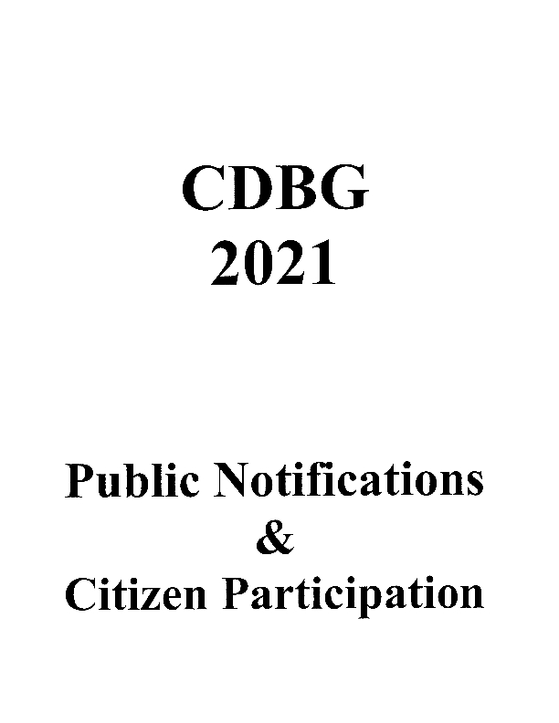
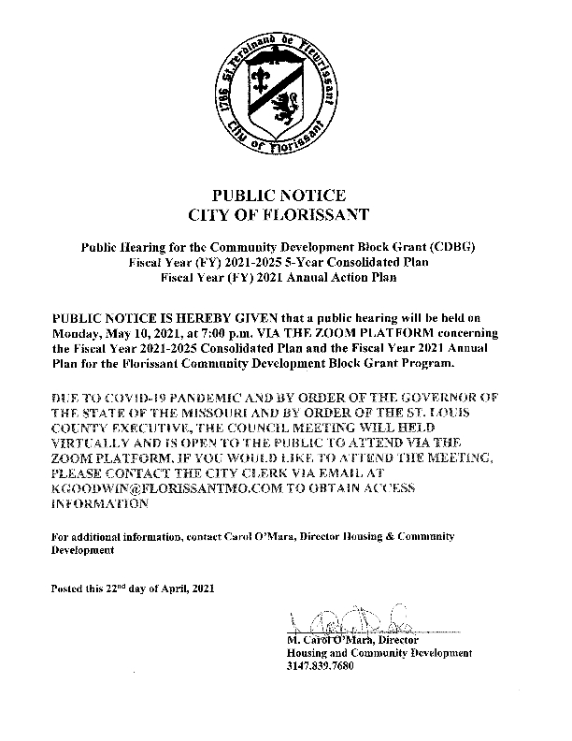
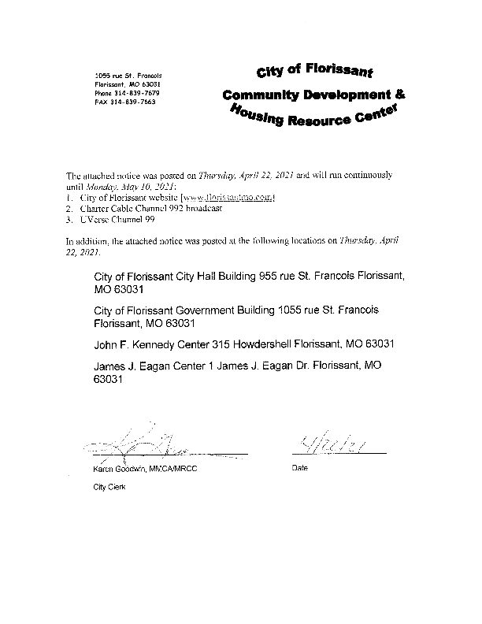
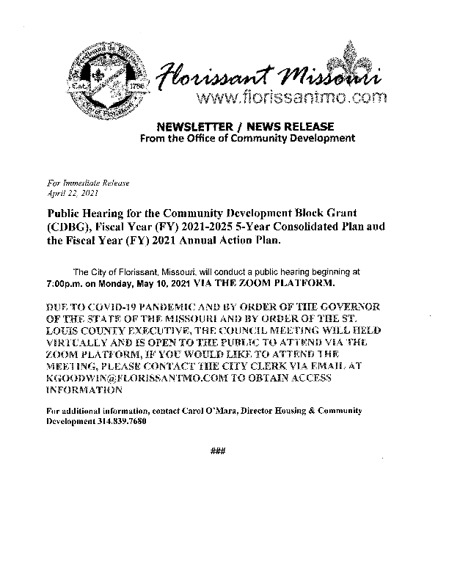
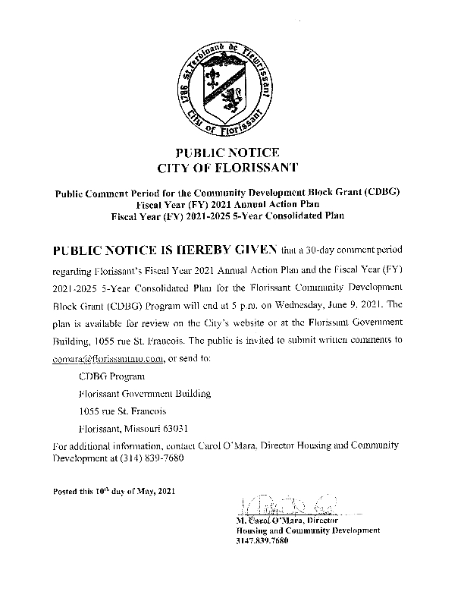
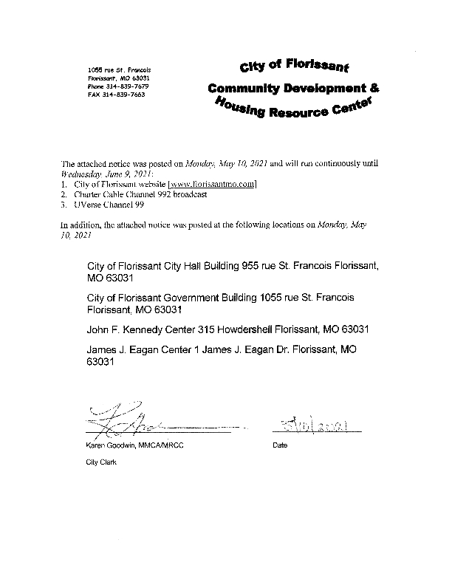
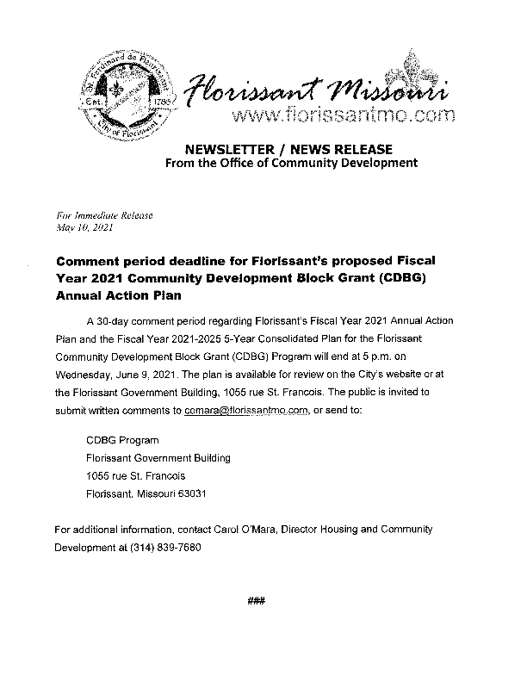
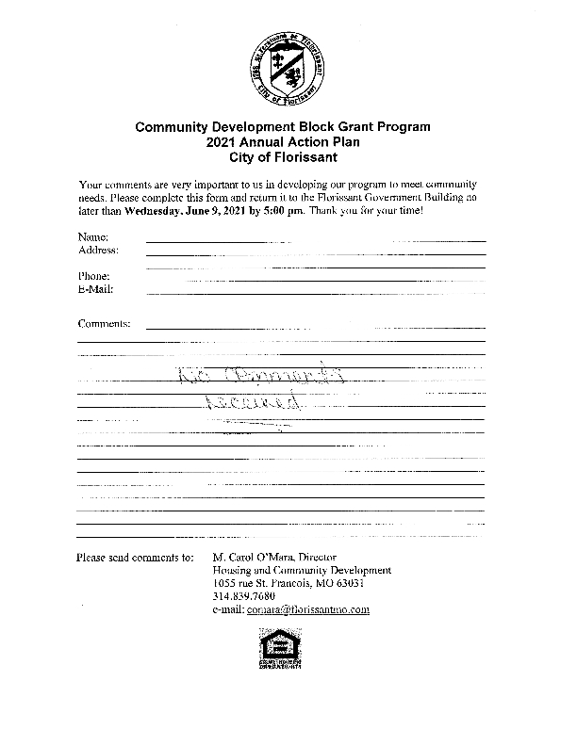

Citizen Participation Comments

Citizen Participation Comments

Grantee SF-424's and Certification(s)
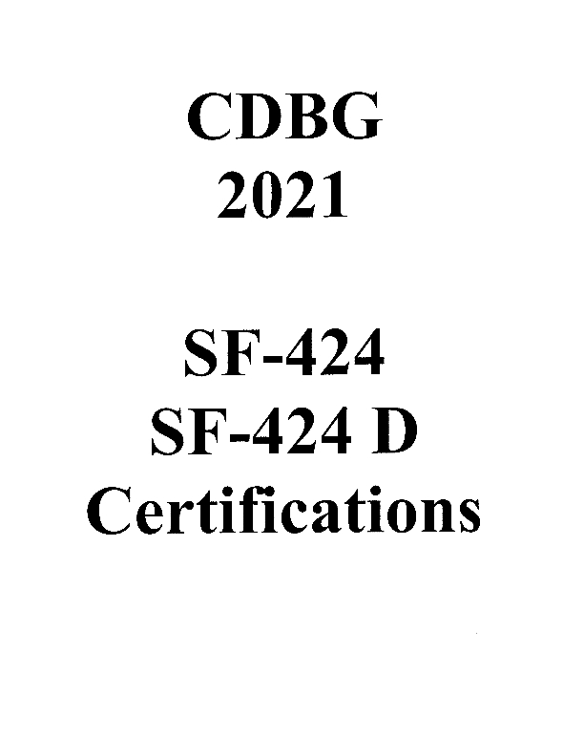
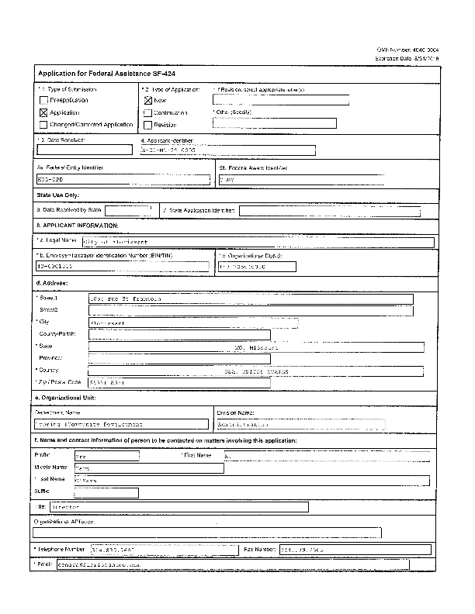
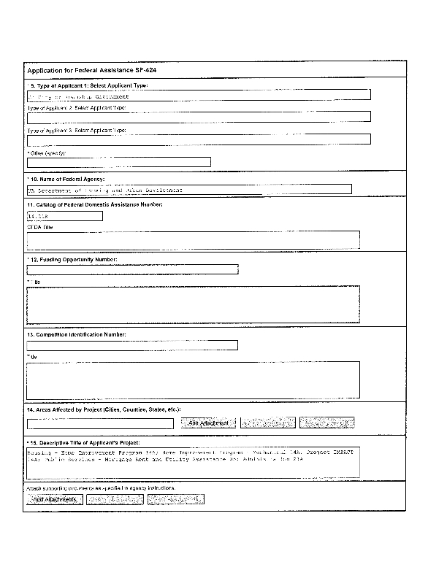
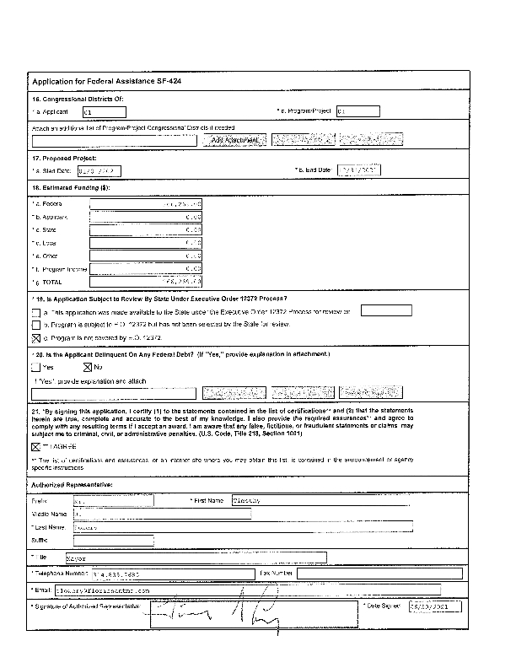
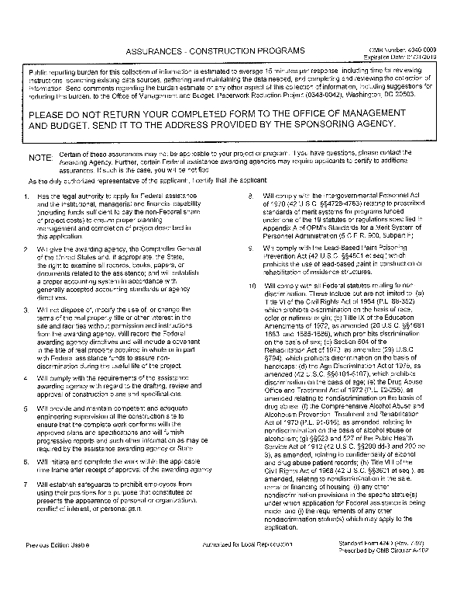
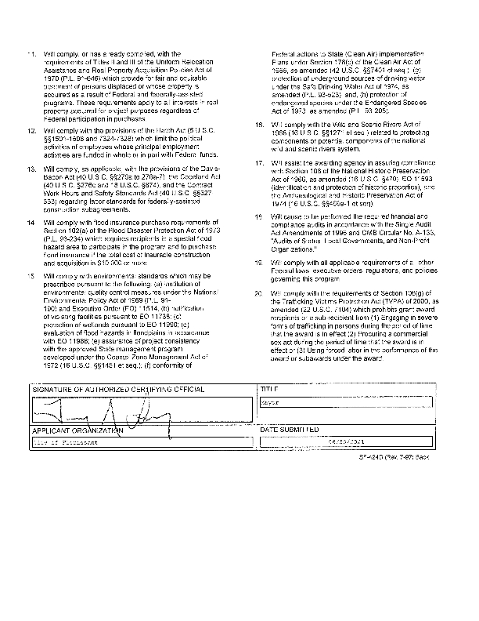
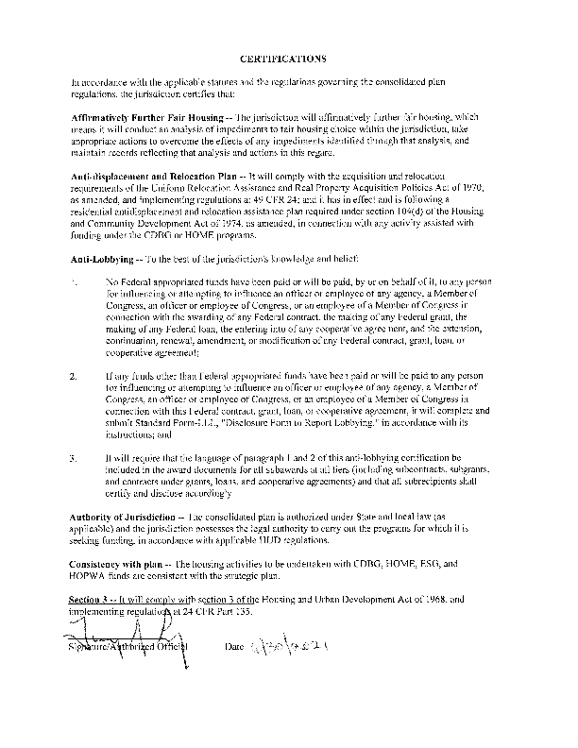
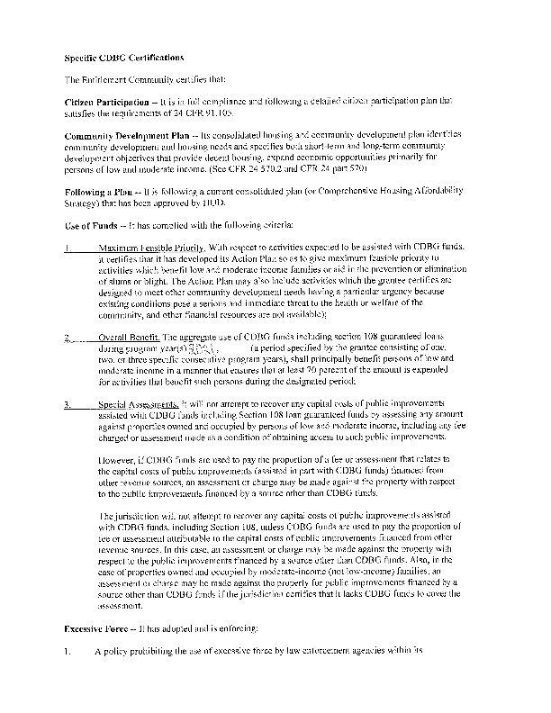
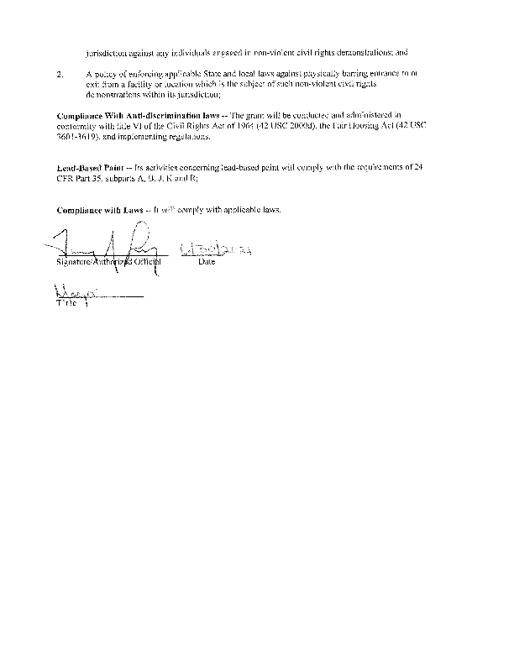
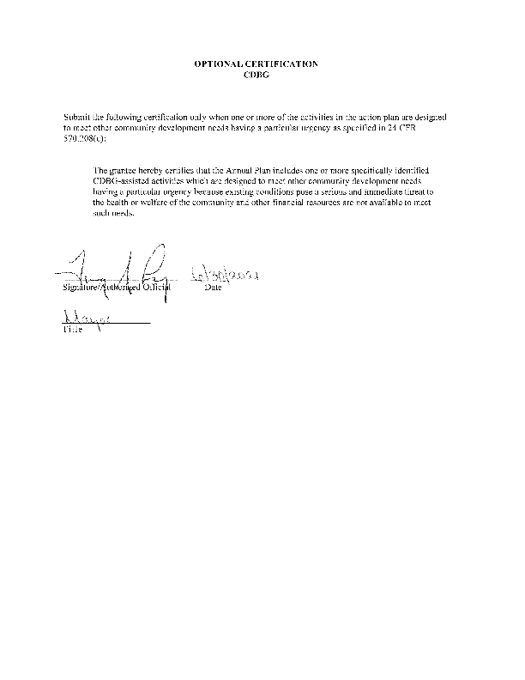
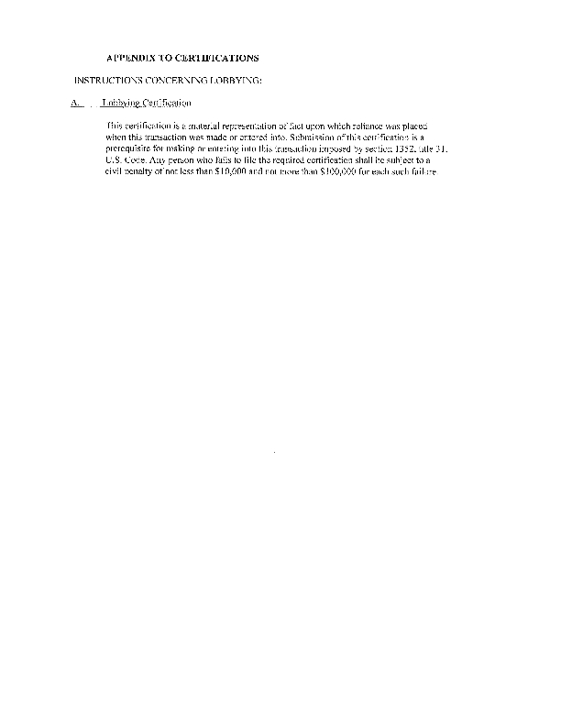

Appendix - Alternate/Local Data Sources

1 | Data Source Name  Census 2010
List the name of the organization or individual who originated the data set.
U.S. Census Bureau
Provide a brief summary of the data set.
Population demographic including race and housing tenure.

What was the purpose for developing this data set?
Federal needs

How comprehensive is the coverage of this administrative data? Is data collection concentrated in one geographic area or among a certain population?
100 percent count of population
What time period (provide the year, and optionally month, or month and day) is covered by this data set?
2010
What is the status of the data set (complete, in progress, or planned)?
complete
2 | Data Source Name  ACS
List the name of the organization or individual who originated the data set.
American Community Survey 2019
Provide a brief summary of the data set.
Demographic & housing data needed to complete the Con Plan
What was the purpose for developing this data set?
Federal needs
How comprehensive is the coverage of this administrative data? Is data collection concentrated in one geographic area or among a certain population?
The data covers the entire geopgraphic distribution of the city
What time period (provide the year, and optionally month, or month and day) is covered by this data set?
2019
What is the status of the data set (complete, in progress, or planned)?
Complete
3 | Data Source Name  Analysis of Impediments to Fair Housing
List the name of the organization or individual who originated the data set.
Mosaic Community Planning
Provide a brief summary of the data set.
The complete AI to Fair Housing for the entire St Louis HOME Consortium
What was the purpose for developing this data set?
Federal Needs
How comprehensive is the coverage of this administrative data? Is data collection concentrated in one geographic area or among a certain population?
The data covers the entire St. Louis HOME Consortium, but also focuses specifically on and throughout the entire geographic distribution of the City of Florissant
What time period (provide the year, and optionally month, or month and day) is covered by this data set?
2010-2019
What is the status of the data set (complete, in progress, or planned)?
Complete

